MVP Interview-to-Evidence: A Configurable AI-Assisted Workflow for Expert Interviews and Evidence-Based Coding
Content
1.1 General Information 2
1.2 Abbreviations and Terms 2
2 Technical Architecture of the Multi-Agent System 3
2.1 Technology Foundations 4
2.2 Architecture and Processing Paths 5
2.3 Components and Responsibilities 5
2.4 Interview Guide as Data Collection Configuration 6
2.5 Voice Interviews with OpenAI Realtime 7
2.6 Canonical Transcript and Technical Gaps 8
2.7 Text Interviews and Mastra Roles 8
2.8 Persistence and Recovery 9
2.9 HTTP Interfaces and Error Handling 10
2.10 Monitoring and Event Streaming 10
2.11 Generic Evaluation Profiles 11
2.12 Evidence Coding and Reporting 12
2.13 Languages and Institutional Reuse 14
2.14 Security Boundaries and Traceable Use 14
3 Using the Interview, Monitoring and Evaluation Studio Applications 15
3.1 Conducting a Live Interview 15
3.1.1 Prepare an Interview and Choose Its Language 15
3.1.2 Change the Interview Guide 16
3.1.3 Starting and Conducting an Interview 17
3.1.4 Monitoring during Interviews 19
3.2 Evaluating with the Evaluation Studio 21
3.2.1 Evaluate an Existing Interview in Evaluation Studio 21
3.2.2 Viewing Results, Evidence and Exports 23
3.3 Changes, Options and Customizations of the MAS 26
3.3.1 Select Edit and Create Profiles for Other Research Topics 26
3.3.2 Configure Aggregation Weights and the Overall Calculation 29
3.3.3 JSON and Excel Import and Studio Language Selection 32
3.3.4 Manage Interview Datasets 33
4 Verification Pilot Findings and Interpretation Limits 34
4.1 Types of Technical Evidence 34
4.2 Software and Persistence Verification 35
5 Changes & Tests 36
5.1 Test/Change: Validation of anchoring values 36
5.2 Test/Change: Testing the reasoning model 36
5.3 Test/Change: First Validation of the Voice Agent & Scoring Agent 37
5.4 Test/Change: Second Validation of the Voice Agent & Scoring Agent 38
5.5 Test/Change: Rework of the Questionnaire (inkl. Test if the MAS can provide more than just 4/7 as value ouptut) 38
5.6 Test/Change: Multi Test 1 39
5.7 Test/Change: Output improvements & evidence citation 39
5.8 Test/Change: Refining questions 40
5.9 Test/Change: Consistency 40
5.10 Test/Change: Evaluation trigger changes 41
5.11 Weiterentwicklung seit dem vorherigen Test (noch nicht „getestet“) 41
6 Additional Information 42
6.1 Template of the interview guide 43
6.2 Derived Anchoring Values 43

General Information
In this document we want to document all changes & tests we conducted in regard to the MAS. Further we want to document the setup of the MAS: What elements constitute the MAS, how are these elements set up, how do these elements interact with each other and what logic does the system follow.

Abbreviations and Terms
MAS: Short for multi-agent system. This describes the whole system developed by the researcher. It contains the Voice Agent to conduct the interviews, the Scoring Agent to evaluate and score provided data and different interfaces to conduct analysis and view results.
Voice Agent: Realtime interviewer that listens and speaks during a voice interview.
Scoring Agent: The evidence coder that applies a selected evaluation profile to confirmed interview statements after an explicit evaluation request.
Questionnaire: Document that contains the interview guide containing main questions and optional predefined refining questions.
Interviewee: The person answering the interview questions.
Main Question: A primary question in the interview guide. Directly derived from a scale item.
Refining question: A predefined follow-up linked to a main question in the interview guide.
Follow-up question: A context-specific clarification that the Voice Agent can generate from an interview answer.
Anchoring Value/Anchor: A criterion describing one scale value for a particular item. They are based on exemplary empirical evidence.
Likert value: An integer from 1 to 7 assigned to an item in the coding scale.
Score: A numeric item, dimension or overall result. Item scores stay on the 1-to-7 scale. A custom overall formula can use another range.
Item: A statement or coding unit that receives an integer rating from 1 to 7 or an explicit non-score state. They describe something contributing to a dimension of an construct
Dimension: A group of related items within an evaluation profile. A dimension constitutes a part of an construct.
Scoring profile: A subject-specific coding configuration independent of the interview guide, with a prompt, dimensions, items and seven anchor criteria per item.
Turn: A confirmed speaker utterance with a server-side sequence number, text, time reference and unique identifier. Partial captions are not canonical turns.
Run: An identifiable execution of a workflow, agent or evaluation step with inputs, outputs, status and runtime. A named role is not automatically a separate model call.
Monitoring event: A persisted interview event with an identifier, sequence number and timestamp. It is transmitted live and can be replayed after reconnection.
Evaluation Profile: Build profile in the MAS which is set up by the researcher. It contains the dimensions, items and associate anchoring values. Here you can also specify the aggregation rule and scoring.

Technical Architecture of the Multi-Agent System
The following section focuses on the technical Setup of the MAS and its interconnected design decisions. It contains details to understand the technical architecture MAS, its interconnected elements and data flows.
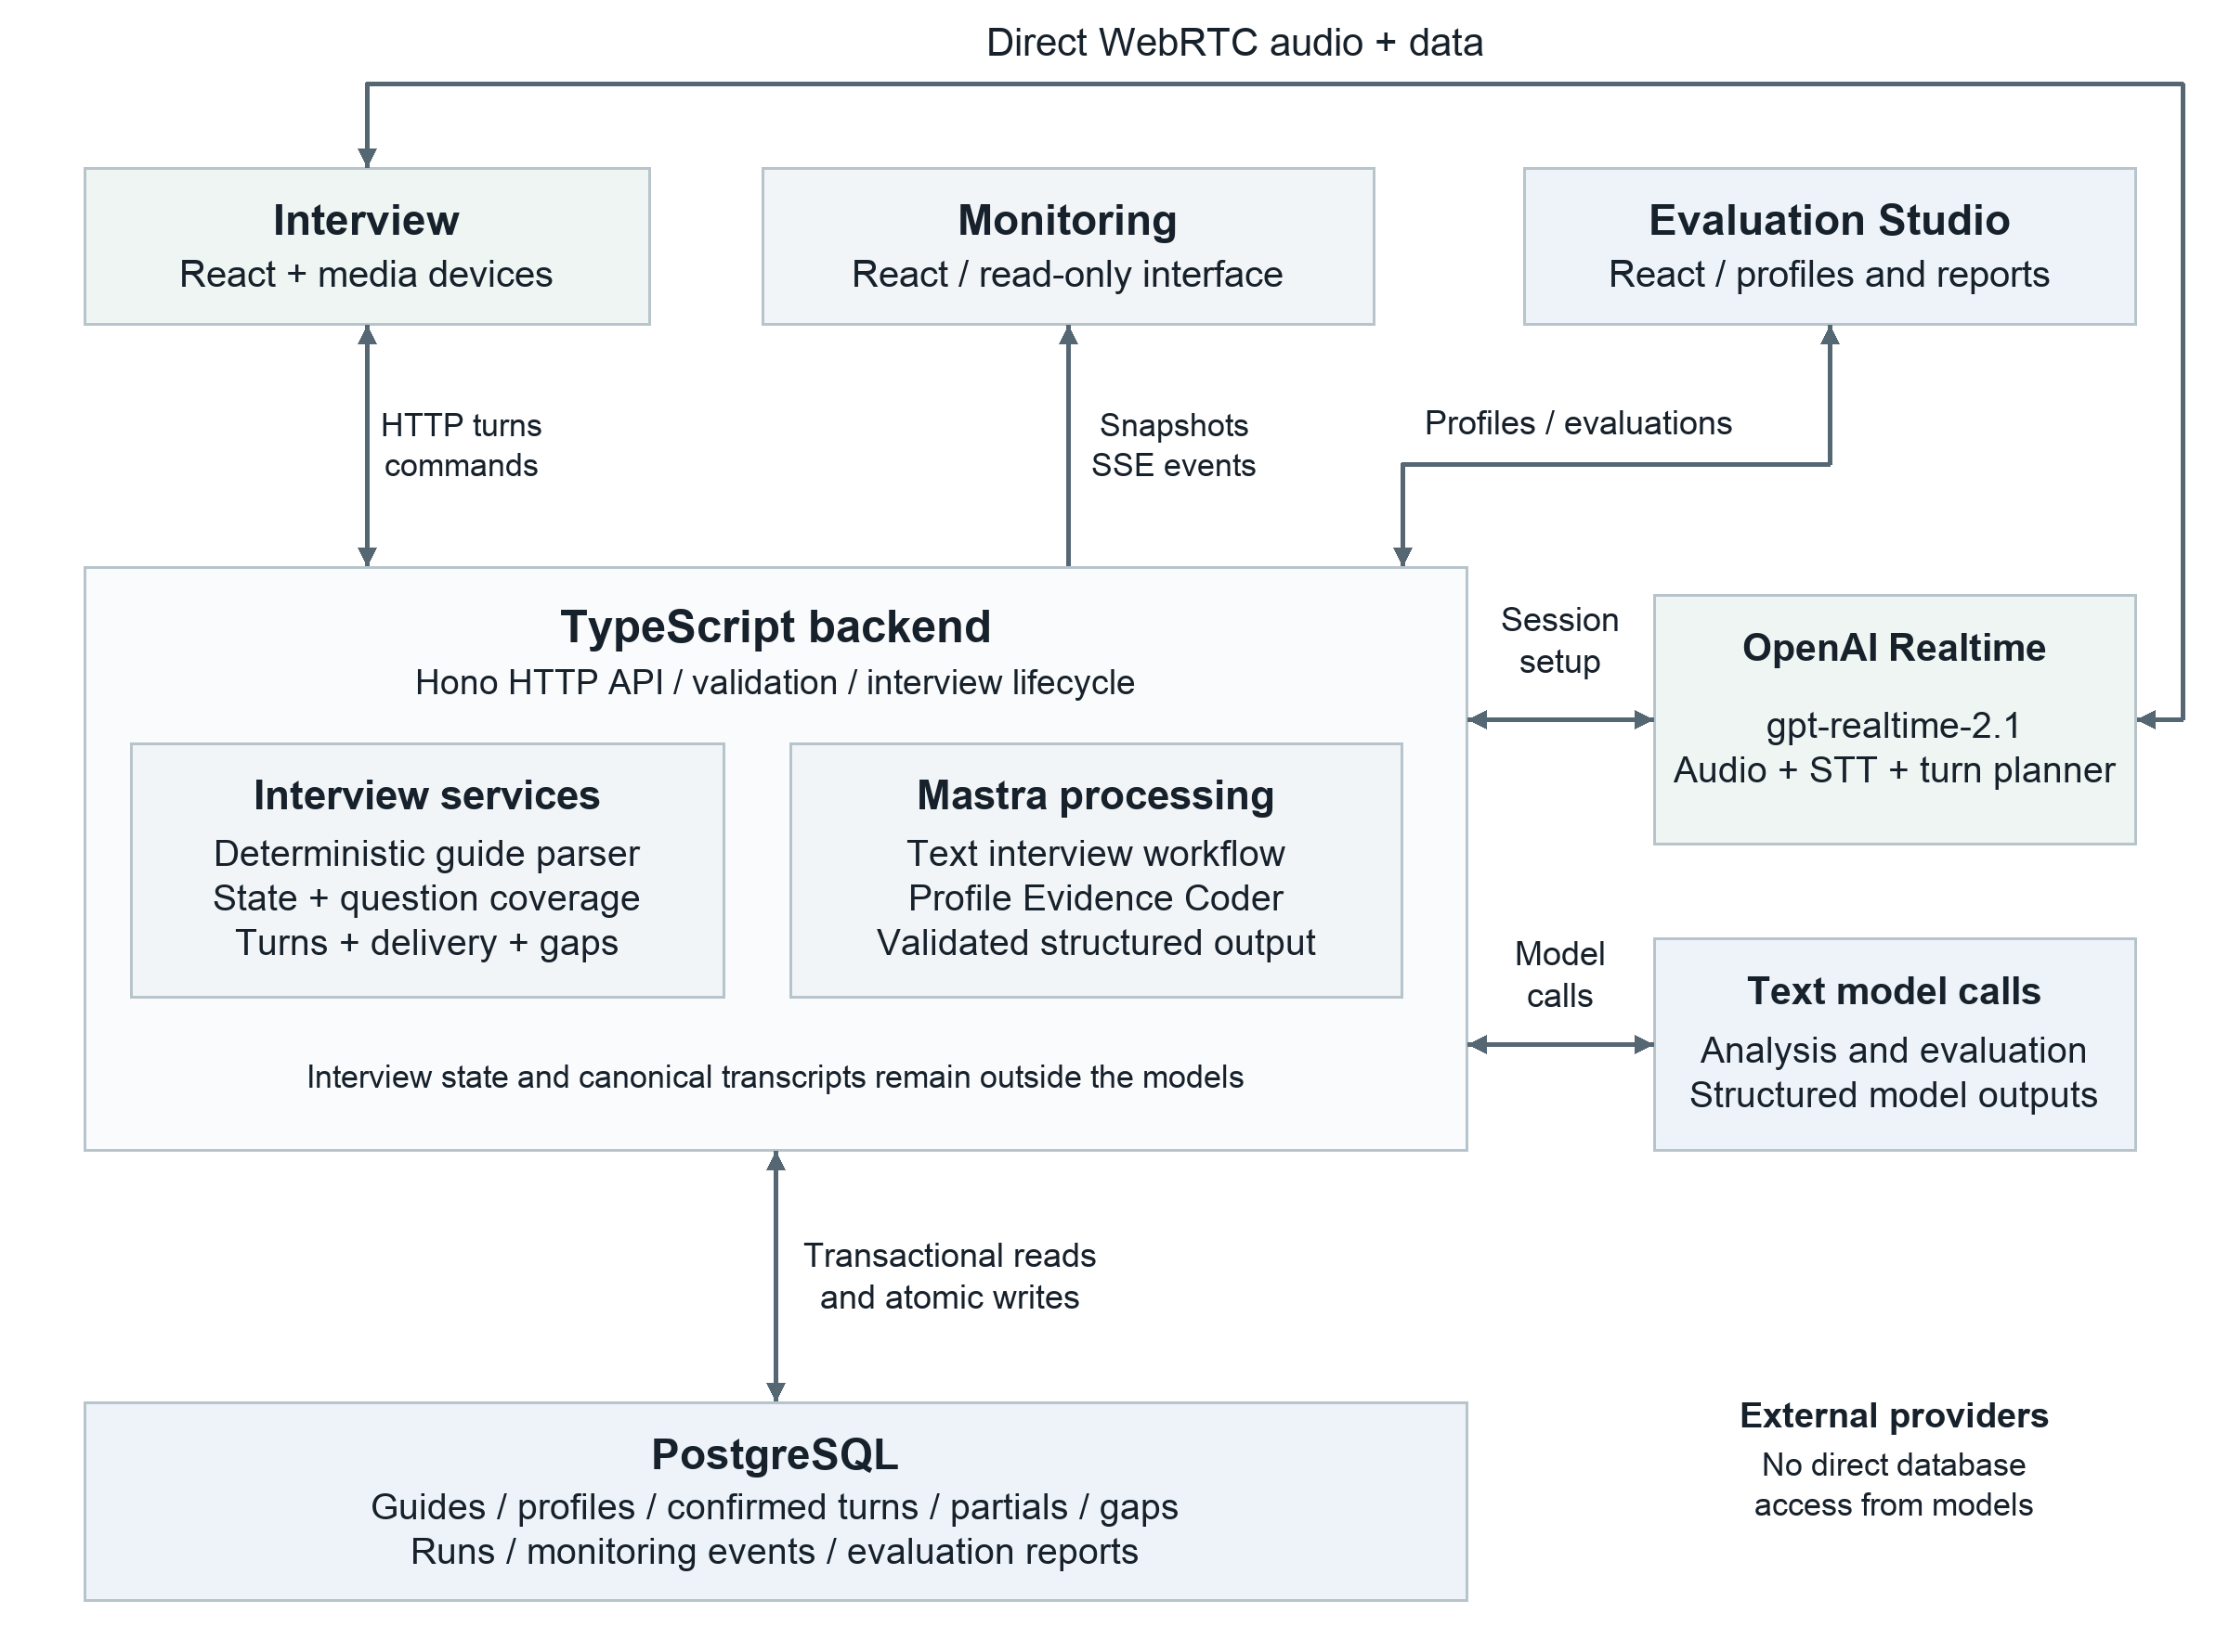
Figure 1: System Architecture. The browser exchanges Realtime audio directly with OpenAI. The backend stores confirmed turns, while text interviews and evaluations use separate Mastra paths.

Technology Foundations
The application uses several technologies with different responsibilities. The following definitions explain these responsibilities before the architecture describes how they work together. A framework provides reusable software structures, while a model generates or interprets content. Mastra is a framework, not the language model itself (Mastera, n.d.-a).
TypeScript adds a type system to JavaScript (Microsoft, 2026). It helps developers detect incompatible values while building the application. Node.js runs JavaScript outside the browser and hosts the backend (OpenJS Foundation, n.d.). Shared TypeScript contracts describe the data exchanged between that backend and the browser applications. These types do not by themselves validate incoming network data.
React builds user interfaces from reusable components, such as a transcript panel or an item editor (Meta Platforms, Inc, n.d.). The Interview application, Monitoring and Evaluation Studio are separate React applications. Vite provides the development server and builds their browser assets (Vite contributors, n.d.). React displays the current state, but the backend decides whether an interview action is valid.

Mastra is a TypeScript framework for AI applications (Mastera, n.d.-a). It defines agents with instructions and models, and workflows with explicit processing steps (Mastera, n.d.-b). This application uses Mastra for structured text analysis and evidence coding. Some named workflow roles execute deterministic rules instead of making another model call. The Realtime voice connection follows a separate path.
Hono routes HTTP requests to the appropriate backend service (Hono, 2026). Zod defines schemas that check actual values when data enters or leaves the application (Colin McDonnell, 2026). For example, a request must contain a valid interview identifier, and an item result must follow the required score structure. This separates runtime validation from the development-time checks provided by TypeScript.
PostgreSQL is the relational database that stores interviews, transcripts, profiles and processing records (The PostgreSQL Global Development Group, 2026). A transaction groups related database changes so that they are committed together or rolled back. Drizzle lets the application describe database tables in TypeScript and construct SQL queries (Drizzle Team, n.d.). Persistent Docker volumes retain the database files when application containers are replaced.
OpenAI Realtime provides a continuing session for speech-to-speech interaction (OpenAI, n.d.). WebRTC carries the interview audio between the browser and OpenAI, with a data channel for session events (MDN contributors, 2026b). Server-Sent Events, abbreviated SSE, serve a different purpose here: the backend sends interview and monitoring updates to the interfaces over an HTTP connection (MDN contributors, 2026a). SSE is not the voice transport.
Docker packages services into containers. Docker Compose describes and starts the frontend applications, backend and database together (Docker Inc., 2026). Nginx serves the built frontend files and forwards their API requests to the backend (NGINX, n.d.). Vitest runs the automated TypeScript and React tests (Vite contributors, n.d.). The following sections describe the application itself rather than an installation procedure.

Architecture and Processing Paths
The interview and evaluation system connects separate processing steps through shared data flows and validation rules. An agent role identifies a distinct processing step, but not every role makes a separate language-model call. The system separates voice interviews, text interviews and explicitly requested evaluations. Figure 1 distinguishes the browser's direct Realtime audio connection from the backend's persistence and separate text-interview and evaluation paths.
The application is deployed with Docker Compose.

Components and Responsibilities
The system is a TypeScript monorepository with a Node.js backend and three separate React applications. The Interview application conducts interviews. Monitoring displays operational status and stored processing results. Evaluation Studio manages evaluation profiles, interviews and evaluation reports. All three applications access the same backend data.
The backend uses Hono for HTTP endpoints, PostgreSQL for persistence, Drizzle for the database schema and Mastra for structured model generation and the text-interview workflow. A central runtime configuration assembles these dependencies. Application services access the database through defined repository interfaces and a shared transaction interface. The user interface therefore does not determine whether a state transition is valid, and a model cannot modify database records directly.
Table 1: Components and their technical responsibility
Component | Technical Responsibility
Shared contracts | Zod schemas and shared types for APIs, states, transcripts, profiles, reports and events
Interview domain | Deterministic guide processing, state transitions, question coverage and transcript rules
API client | Validated HTTP and SSE access for the browser applications
Localization and design tokens | Shared language and design conventions
Backend services | Application services, provider adapters, database repositories, monitoring and report exports
Browser applications | Separate user interfaces with a shared data source
The domain has no dependencies on React, HTTP transport, PostgreSQL or a specific model provider. Transport and infrastructure depend on application services and domain interfaces, not the other way around. This separation allows deterministic rules to be tested independently of network connections and model responses. The deployment supports one backend instance. Horizontal scaling and a multi-tenant production architecture are not implemented.

Interview Guide as Data Collection Configuration
An interview guide is imported as structured Markdown and parsed deterministically. The system requires a title, sections, main questions and, optionally, associated predefined follow-up questions. In an English guide, the structural headings are ### Main question and #### Refining questions. No language model interprets the document structure or generates missing questions during import. Structural errors are reported with line references.
The validated structure produces stable identifiers for the guide, sections and questions. The original Markdown source is stored alongside the parsed structure. Subsequent interview turns can therefore be linked to a specific main or predefined refining question. Coverage tracks progress through the guide questions. It does not evaluate the research subject. Answering a question does not necessarily provide sufficient evidence for every evaluation item.
The system stores a separate guide selection for German and English. When an interview is created, its guide identifier and language are assigned to it. The guide and interview languages must match. Changing the stored selection affects future interviews, not the question catalogue of an existing interview. The built-in German and English default guides are initialized when needed, without overwriting an existing selection.
The interview guide and evaluation profile are separate. The guide determines which information should be collected. The profile determines the criteria used to evaluate confirmed statements. A new research topic therefore requires an appropriate interview guide and a carefully developed evaluation profile, but not necessarily new program logic.

Voice Interviews with OpenAI Realtime
Voice interviews use a native OpenAI Realtime session with gpt-realtime-2.1 as the configured default model. Integrated participant transcription uses gpt-live-transcribe, and the default voice is marin.
The backend builds session-specific instructions from the stored interview state and requests a short-lived Realtime client secret. The permanent OpenAI API key remains in the backend. The browser uses the temporary secret to establish a direct WebRTC connection with OpenAI. Participant microphone audio and interviewer audio pass through this connection. Realtime events use a data channel. The voice path uses neither LiveKit as an intermediary nor a separate text-to-speech call. The camera provides a local preview and is not transmitted to the Realtime interviewer as video input.
The session uses Semantic VAD to detect the end of an utterance, with low eagerness. Automatic response generation and automatic interruption of an ongoing AI response are disabled. Instead, the application controls the order of persistence, planning and audio playback. Microphone capture is blocked during playback to prevent loudspeaker echo from being treated as a new participant response. Browser permissions and a working microphone connection are required.
Processing a participant response involves five separate steps. First, transcription deltas provide provisional captions. Second, the final participant transcript is sent to the backend with the provider item ID and stored. Third, only after successful storage does the browser request a structured plan_interview_turn tool call within the same Realtime session. Fourth, the backend validates this proposal against the guide, coverage, the last confirmed response and the question history. Fifth, it reserves an allowed AI output before the browser requests the corresponding audio response separately. A response that has not yet been persisted cannot advance normal data collection progress.
A planning proposal contains an action, a question identifier, proposed spoken text, a classification of the response and, where applicable, a missing aspect and the intended evidence reference. Allowed actions are a main question, a predefined follow-up question, a free clarification question, a repetition and interview completion. Main and predefined follow-up questions are resolved to the canonical guide text on the server. A proposed jump to a main question does not authorize arbitrary skipping of unanswered main questions. A completion proposal does not end the interview prematurely if the backend catalogue still identifies a next unanswered main question.
Free clarification questions are more restricted than general conversation. They must identify a specific missing aspect, remain within the current topic and avoid near-repetition of earlier clarifications. General prompts such as "Could you tell me more about that?" are not accepted as sufficiently specific clarifications. Each associated question allows at most three free clarifications and one repetition. This budget is reconstructed from stored, confirmed turns and their planning metadata rather than maintained only in a temporary browser counter. Refusal, lack of knowledge, non-applicability and content already answered can lead to the next main question. A misunderstanding or an off-topic response permits a limited repetition.
After reservation, the browser requests playback only of the approved text. An AI turn can be confirmed as complete only after the provider response finishes successfully. The backend performs an exact text comparison, without normalizing capitalization, umlauts or punctuation. A mismatch is treated as a technical gap and can trigger a limited redelivery attempt or recovery of the interview state. A failed delivery attempt is therefore not silently recorded as a fully delivered question. This check validates the reported text output, not every word actually heard against a stored audio recording.

Canonical Transcript and Technical Gaps
The canonical transcript is the authoritative chronological data source for conversation views and transcript exports. It contains confirmed turns and explicitly marked technical gaps. A turn includes the speaker, sequence number, timestamp, identifier and, where applicable, a guide reference. Participant contributions are recorded as final responses, while AI contributions are linked to their delivery state. A planned question is not yet a completed conversation turn.
Partial transcriptions remain separate. They support captions and operational monitoring but can be superseded by later final events. They are not used as research quotations or evaluation evidence. A delayed partial event must not overwrite an already confirmed participant turn. The system neither generates missing participant statements with a language model nor smooths the stored final transcript for evaluation.
An open AI delivery reservation blocks normal finalization of the next response. The application must first determine whether the output is complete, interrupted or should be resolved as a technical gap. Unresolved deliveries and unconfirmed partials are handled accordingly when the interview ends. Deterministic finalization then checks properties including order, speakers, references and gaps. The finalization report lists the checked entries and findings. It must not return replacement transcript text. This role also runs deterministically in the provider executor.
Transcript exports render the canonical data without changing it. The Interview application exports Markdown, JSON and plain text, retaining visible technical gaps. JSON includes language and guide references. The system has no native Word or PDF transcript export. The application does not permanently store a complete audio recording of the conversation. Retrospective verification of possible speech-recognition errors is therefore limited unless an audio source has been separately retained with appropriate authorization.

Text Interviews and Mastra Roles
The separately selected text mode uses the same canonical persistence and state services but a different planning path. A Mastra workflow starts after a final text contribution is stored. Coverage Analysis and Consistency Analysis run in parallel, followed by Interview Decision and Interview Conductor. The HTTP request waits for the workflow to finish. Processing is not handed to an independently running production worker.
Coverage Analysis examines coverage of allowed guide questions and references confirmed transcript turns. Consistency Analysis identifies possible contradictions and, where applicable, specific clarification questions. Their structured model responses are then validated deterministically. The default model for these analyses is openai/gpt-5.4-nano. Generation is bounded, time limits apply, and invalid structured responses receive at most one repair attempt.
Interview Decision and Interview Conductor are deterministic functions in the provider executor. Decision processes validated coverage and consistency results together with the allowed question catalogue. Conductor returns the selected question or closing text according to predefined rules. These steps retain their role names and stored run metadata, but do not each generate an additional external LLM call. The same applies to Transcript Finalization. The term multi-agent system therefore describes a division of responsibilities that combines probabilistic analysis with deterministic control.
An explicit demo mode can replace interview analysis and evaluation with local demo implementations. These results are test data, not provider evaluations or empirical findings. If the Realtime connection fails, the voice path does not silently switch to a demo, browser-speech or text provider.

Persistence and Recovery
Research and operational data are stored in the PostgreSQL schema app. These include guides, language settings, interviews, states, coverage, final transcript segments and turns, partials, technical gaps, AI deliveries, workflow and agent runs, finalizations, evaluation profiles, evaluation runs and events. A separate Mastra database is not the canonical conversation source. Versioned migrations make schema changes traceable. The readiness check requires application schema version 15 and verifies initialization of the required default configuration.
Read operations use consistent REPEATABLE READ READ ONLY transactions. Writes also use REPEATABLE READ, together with interview-specific locks, version checks and database constraints. Sequence numbers are assigned within the same transaction that writes the turn or event. Uniqueness rules for provider events, deliveries and interview-specific sequences prevent normal duplicate ingestion. These rules make defined requests with known identities idempotent. They do not guarantee automatic, lossless recovery from every network failure.
On reconnection, the browser reloads the authoritative backend state, including any open delivery and the last confirmed response. A timeout can trigger a controlled reconnect or recovery action. The application must distinguish between an already stored response and an output that has not yet been confirmed. Browser state is therefore not the sole source of interview progress. Multiple applications can display the same stored state without creating separate interview histories.
Recovery is limited. Job and lease data exist, but the runtime has no background worker that automatically resumes abandoned Mastra requests after a process crash. Nor is there a server-side timer worker that automatically converts every permanently abandoned AI delivery into a gap. Reconnection, further user actions and explicit completion paths are therefore important parts of recovery.
When the interview moves to another section, a deterministic Section Memory can be stored. It contains guide-related coverage and unchanged participant quotations with canonical identifiers. The Realtime context retains the current section, the four most recent turns and memories of earlier sections. Provider context is cleared only after the context update has been confirmed. If compaction fails, the existing context remains. This optimization shortens neither the canonical transcript nor the evidence source for a later evaluation.

HTTP Interfaces and Error Handling
The application's public interfaces are under /api/v1. Guides are imported and read through /guides. Interviews are created and listed through /interviews, and their canonical sessions are loaded through /interviews/:interviewId/session. The commands start, pause, resume and end are explicit lifecycle actions. Participant contributions, partials and provider confirmations have separate endpoints. A provisional caption update is therefore not treated as a confirmed research statement.
The voice path includes /voice/session for the temporary connection secret and separate /realtime/... routes for participant turns, turn intents, AI turns, interruptions, gaps, open plans and completion. These endpoints always refer to the interview identifier in the path. Relevant Realtime write requests check the browser protocol version. If the interface is outdated, the response can explicitly instruct the browser to reload. This check maintains frontend-backend consistency but does not authenticate users.
Evaluation profiles are managed under /evaluation-profiles. At /interviews/:interviewId/evaluation, GET reads data and POST starts an explicitly requested run. /evaluation/retry triggers another processing attempt, while /evaluation/export returns an existing completed report. The profile identifier and export format are structured selection parameters. Model processing occurs within the backend request, not through a direct browser connection to the evaluation model.
Inputs and responses are validated against the shared Zod contracts. Errors include a stable error code, a message and a request ID for correlation. Content-Type and size checks limit uploads. Health endpoints distinguish process availability from database readiness. This technical error handling does not assess the subject-matter plausibility of content. A syntactically valid guide question can still be unsuitable for the intended construct.

Monitoring and Event Streaming
Monitoring is a read-only operational interface. It displays interview state, coverage, the transcript, delivery state, workflow and agent runs, and stored events. It shows structured inputs and outputs, references, explanations, validation findings and errors. These are application-defined records, not access to a model's hidden chain of thought. The runtime does not install a complete PostgreSQL trace exporter or store an unrestricted Mastra fullStream in the research database.
The backend uses Server-Sent Events because updates predominantly flow from server to browser. Each event belongs to an interview and has an incrementing sequence number. A transactional outbox stores it together with the associated application change. PostgreSQL notifications and periodic database queries inform active connections of new entries. The persistent event source is the database, not a temporary in-memory hub.
When opened, the interface first loads a snapshot with its event position, then continues the stream after that sequence. afterSequence or Last-Event-ID enables ordered replay. The backend determines a high-water mark and returns stored entries in order. Old events, events belonging to another interview and events unrelated to the current selection must not overwrite the new screen state. Slow clients are subject to limits or disconnected without delaying the interview commit until they process the events.
Read-only monitoring is not an authorization boundary. The API also exposes interview and profile services that write data. Without authentication, separating the user interfaces does not establish institutional roles or access control.

Generic Evaluation Profiles
An evaluation profile is a stored subject-matter coding configuration. It contains a name, a description, an editable coder prompt, and ordered dimensions and items. Each item has a unique identifier, an assigned dimension, a name, a coding instruction and seven complete anchor criteria. The profile schema permits at most 50 dimensions and 500 items. Every dimension must contain at least one item. The backend validates identifiers, assignments and ordering.
The content configuration is generic: other research questions can use their own dimensions, items and anchors. AI coding remains restricted to integer scores from 1 to 7 or defined non-score states. The subsequent overall calculation is configurable per profile: a weighted mean or a mathematical formula replaces the previous overall score. Item and dimension weights default to one. Calculation settings are not sent to the evidence coder and therefore cannot instruct it to prefer a particular rating. Editable subject-matter prompts do not change providers, tool access or persistence rules.
The schema size limits are technical upper bounds, not evidence of performance for arbitrarily large studies. The subject-matter coder prompt and anchor texts are also limited: the prompt can contain up to 20,000 characters, and each coding instruction or anchor criterion up to 4,000 characters. Large profiles and long transcripts nevertheless increase provider input. Runtime, costs and semantic quality must therefore be assessed for the actual volume used.
Evaluation Studio supports creating, editing, duplicating and deleting profiles, JSON export, and JSON and XLSX import. The required default profile can be edited and duplicated but not deleted. A version timestamp protects changes against concurrent editing. Imports include a preview and explicit confirmation. Version 2 templates use the sheets Instructions, Profile, Dimensions, Items and Anchors, including calculation mode, expression and weights. Mathematical expressions are stored as plain text. Active Excel formulas, macros, external links and embedded content remain prohibited. Strict version 1 files remain importable with default calculation semantics.
The built-in default profile contains nine Organizational Resilience items. The research artifacts, including the instrument, intermediate-score codebook, mapping and English overlay, are loaded with schema validation and SHA-256 fingerprints. The derived 1-to-7 evidence-based profile is not equivalent to the published 1-to-5 self-report scale. Custom profiles and their anchors require subject-matter review in the relevant research context. The interface has neither a complete profile version history nor an approval and publication workflow.

Evidence Coding and Reporting
Evaluation is independent of the ongoing Realtime interview and is explicitly requested. Opening or refreshing an existing report does not trigger a model call. The operator selects an interview and a profile. Evaluation is not restricted to fully finalized interviews: confirmed interviewer and participant turns are sufficient for a provisional evaluation of the available transcript. Active, paused and incomplete conversations can therefore be evaluated. The report records source status and finalization. Missing responses must not be interpreted as negative evidence.
The Mastra Profile Evidence Coder receives the subject-matter profile snapshot and only final participant turns, including their identifiers, sequence numbers and text. Weights and calculation formulas are excluded at both the application and provider boundaries. It receives neither partial transcriptions as evidence nor conversation audio. Stored AI turns provide structural interview context to the service but are not the coder quotation source. The model evaluates every profile item in the specified order. The default model is openai/gpt-5.6-terra. Model selection and time limits are server-side settings. The coder has no external tools.
Immutable instructions treat editable profile content as untrusted subject-matter data. It cannot override protected evidence, score or structure rules. For each item, the model returns either scored with an integer from 1 to 7, or insufficient_evidence, not_applicable or conflicting with null. It provides supporting evidence, counter-evidence, missing information, a readable rationale and model-generated confidence between 0 and 1. Evidence is classified as supporting evidence or counter-evidence. There is no separate category for unclear evidence. Contextual inferences can be briefly explained and supported by additional original quotations. A single sufficient quotation can support a coding decision. Adding quotations does not automatically improve its quality.
After generation, the backend validates the result deterministically. Every item must appear exactly once and in profile order, its dimension assignment must be correct, and scores and non-scores must conform to the schema. Every evidence quotation must be an exact substring of the specified final participant turn. The backend also checks its sequence number and identifier. The same passage cannot serve as both supporting evidence and counter-evidence for one item. A preliminary restoration step can map only unambiguous initial-capitalization and whitespace differences back to the original quotation. It creates no new statements and does not change the transcript. Strict quotation validation still applies afterward.
Invalid structured results may receive a limited repair attempt. A result that is still rejected afterward is stored as a controlled error, not as a partially accepted research report. This validation protects references and format but cannot establish that the semantic interpretation or anchor selection is correct. Confidence is neither a statistically calibrated probability nor a confidence interval. Human subject-matter review remains necessary.
The report builder computes dimension and overall results deterministically after coding. The default weighted mean assigns each scored item an effective coefficient equal to its item weight multiplied by its dimension weight. The overall result is the sum of score times effective coefficient divided by the sum of included coefficients. The calculation excludes missing scores and zero-weight contributions, then renormalizes the remaining coefficients. With all weights set to one, this reproduces the previous flat mean across scored items, including profiles whose dimensions contain different numbers of items. Dimension results use item weights within that dimension, not the dimension weight. Without a positively weighted scored contribution, the weighted result remains empty.
In formula mode, researchers define the overall result using stable item and dimension IDs. Supported references are item("id"), dimension("id"), itemWeight("id") and dimensionWeight("id"). Missing item or dimension values are substituted with zero only while evaluating the formula. The original item remains unscored. Dimension references use their unrounded item-weighted means. Dimension weights affect a custom formula only when explicitly referenced. Formula results are not restricted to 1 to 7: for example, they can represent a 0 to 100 index. Intermediate values remain unrounded and the final result is rounded to two decimal places.
The shared calculation engine permits numbers, parentheses, arithmetic operators and min, max, abs, pow, sqrt and round. It uses an allowlisted mathematical syntax tree rather than executing JavaScript. Object access, assignments, arbitrary functions and executable spreadsheet formulas are not allowed. Expressions are limited to 20,000 characters, 4,096 syntax nodes and 64 levels. Unknown IDs prevent saving. Division by zero, non-finite results and other arithmetic failures yield a visible calculation error while preserving the coded items and evidence. Coverage status and counts describe which items were scored, independently of whether an overall result could be calculated.
A saved calculation trace records configured and effective weights, missing and zero-weight exclusions for weighted means, and the actual values used by formula references, including zero substitutions. The same trace is displayed in Studio and Monitoring and included in all report formats. The local editor preview uses researcher-supplied test scores and makes no model call. Formula configuration changes the aggregation method, not the validity of the underlying research instrument.
Newly generated reports use schema version 5 and prompt version profile-evidence-coding-v7. They store the exact applied profile, weights, calculation mode and expression, calculation trace, applied anchors, profile and transcript fingerprints, language, model metadata and evaluation timestamp. Descriptive age and position data are extracted only from explicit self-reports with original source evidence and are not separate scoring criteria. Missing or ambiguous data remain empty. Rationales and calculation traces are reviewable outputs, not hidden internal model reasoning.
One current evaluation run is stored for each interview and profile. Reading a report does not start or retry a run. An explicitly requested new run replaces the previous report for the same interview and profile. A separate complete run history is not retained. Meaningful changes to profile content, weights, formulas or the transcript invalidate the current result without triggering automatic rescoring. Default-equivalent weights preserve existing fingerprints. Historical version 3 and 4 reports remain stored unchanged and are projected read-only into the current format. JSON, CSV, Markdown and HTML exports represent the same saved scores and calculation trace. A printable HTML report is not a native PDF or DOCX export.

Languages and Institutional Reuse
The language contract supports German and English, with English as the initial interface language. Interviews retain their stored language. Structural headings, conversation instructions and report rationales follow this language assignment. Localizing the interface does not automatically translate an existing research guide or all custom profile text. Evidence quotations always remain in the language of the confirmed original turn.
The built-in default profile receives a controlled English overlay when its subject-matter content remains unchanged. Editing only weights or the calculation formula preserves this eligibility. The overlay is applied to the evaluation input without rewriting the stored profile. Its provenance is recorded in the report. Custom profiles, duplicates and edits to the default subject-matter content are not silently translated. Bilingual use of another instrument requires appropriate language versions and an independent assessment of their comparability.
Institutional reuse is possible within these limits. Another project can import its own guide and create a separate profile with different dimensions and items. The generic coding mechanism remains technically unchanged. A suitable profile alone does not ensure that the guide collects sufficient evidence. Shared identifiers or translation likewise do not establish measurement invariance, reliability or validity. Sound research requires documented instrument development, piloting, subject-matter review and, where appropriate, independent double coding.

Security Boundaries and Traceable Use
The system is a local, single-tenant prototype without application-level authentication or role management. An Origin allowlist restricts browser requests but does not authorize users. CLI and service clients can make requests without Origin. The existing interfaces alone therefore do not secure the system for publicly accessible institutional research use. Data protection responsibilities, consent, access rights, retention and deletion must be defined before actual data collection and supported by appropriate technical measures.
Although the application does not store audio recordings, the external Realtime provider processes spoken audio. Text-model calls can contain interview content and subject-matter configurations. The pipeline includes neither automatic anonymization nor comprehensive compliance approval.
Evaluation Studio supports renaming and explicitly deleting stored interviews. The backend blocks deletion during an active or ending interview, a running job or an ongoing evaluation. An allowed deletion removes interview-related data rather than archiving it in a recycle bin. Profiles and guides are separate from these records. Before deletion or a new evaluation, research artifacts intended for release should be preserved and versioned according to institutional data-management procedures.
The technical tests and recorded synthetic runs provide verifiable evidence for defined functions. They do not replace real data collection, independent inter-rater analysis or psychometric validation. Synthetic interviews must remain identified as synthetic.

Using the Interview, Monitoring and Evaluation Studio Applications
The following steps cover preparation, interviewing, live monitoring and evaluation in the three browser applications.
The source code is supplied in the accompanying GitHub repository. Docker runs the Interview application, Monitoring, Evaluation Studio, the backend and the database in coordinated containers. Docker Compose starts this shared application stack together. The three interfaces use the same stored data.
The Interview application is available at http://localhost:5273, Monitoring at http://localhost:5274 and Evaluation Studio at http://localhost:5275 once the initial setup is complete. These are separate interfaces to the same data, not separate copies of an interview. On another computer, localhost refers to that computer's local deployment.
The screenshots show the English interfaces with synthetic interview data and example research profiles.

Conducting a Live Interview

Prepare an Interview and Choose Its Language
The Interview application opens with a preparation screen. Use the camera preview to check your device. Microphone and camera can be selected and switched on or off independently. The camera is a local self-view and is not transmitted to the interview model. Enabling it therefore does not add visual evidence to a subsequent evaluation.
Before starting, select German or English using the language control in the upper-right corner. This sets the interview language. An English interview requires a stored, selected English guide. The interface does not automatically translate an arbitrary uploaded German guide into English. The language is fixed when the interview starts and remains unchanged if the interview is paused. Start a new interview to use a different language. On first use, the interface selects English. A previously saved language choice remains in effect.
Select Text or Voice explicitly. Voice requires the server-side provider configuration and working devices. A missing key or provider error produces a visible error without silently switching to another voice provider or to text. Text mode is a separate operating mode. Figure 2 shows Text mode on the English preparation screen with both devices switched off. Figure 3 shows the corresponding Voice mode selection before the interview starts.
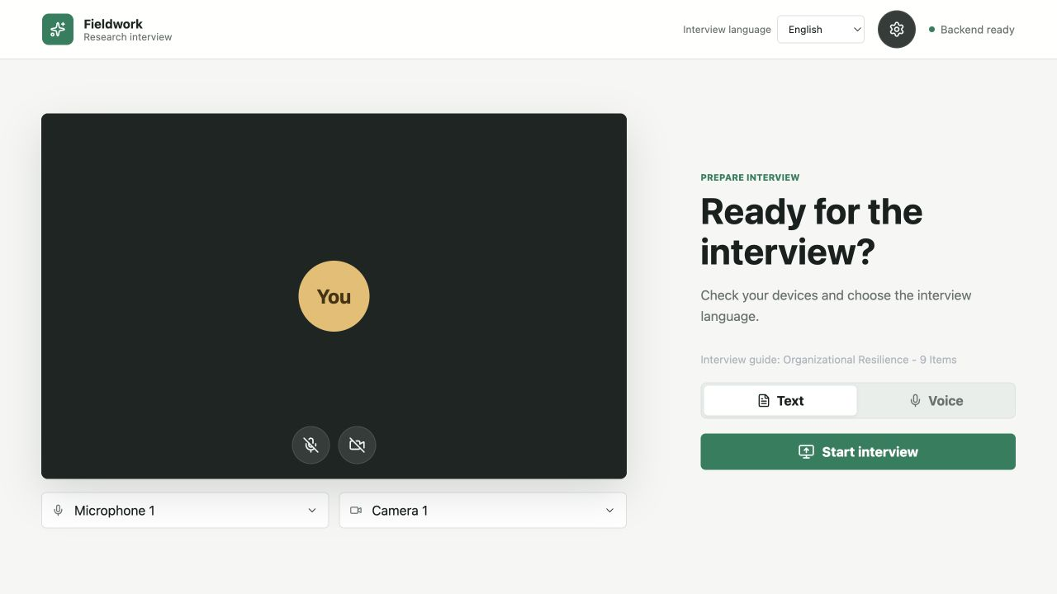
Figure 2: Interview Preparation in Text Mode. English preparation screen with microphone and camera switched off, an English guide selected, and Text mode active.
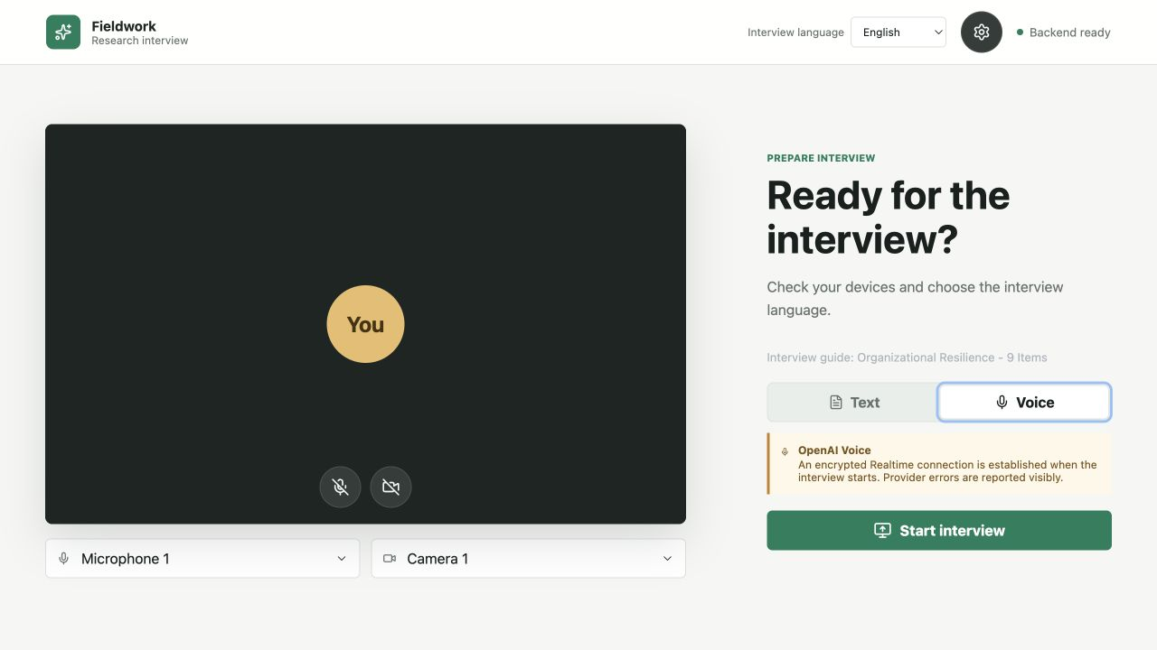
Figure 3: Interview Preparation in Voice Mode. English preparation screen with Voice mode selected. The interview language is chosen before the interview starts.

Change the Interview Guide
Open Interview settings using the gear icon in the upper-right corner. Select an existing guide in the Interview guide field, which displays its title and question counts. Save selection stores that guide in the database as the setting for the selected language. Selecting an entry or closing the dialog alone does not replace the stored setting. Figure 4 shows guide selection and Markdown upload in the same settings dialog, including the explicit Save selection action.
To upload a new guide, choose Select Markdown guide in the same dialog. The upload reads a .md file, validates its format and content, and stores the parsed structure. Select the new entry and explicitly save it as the guide setting. Uploading does not automatically make the newest file the global default.
An English guide uses # for its title, ## for sections and ### Main question followed by the question text. Optional predefined follow-ups appear as a bullet list under #### Follow-up questions. The parser reads these headings deterministically, without a language-model agent guessing the structure. Every main question requires text, and the guide must contain at least one main question. German guides use the corresponding supported format for the selected language. An exemplary guide template can be found in section 6.1.
An evaluation profile is neither selected here nor embedded in the guide. The guide and profile are separate research instruments: the guide organizes data collection, while the profile defines subsequent coding. Researchers are responsible for assessing whether their content fits together.
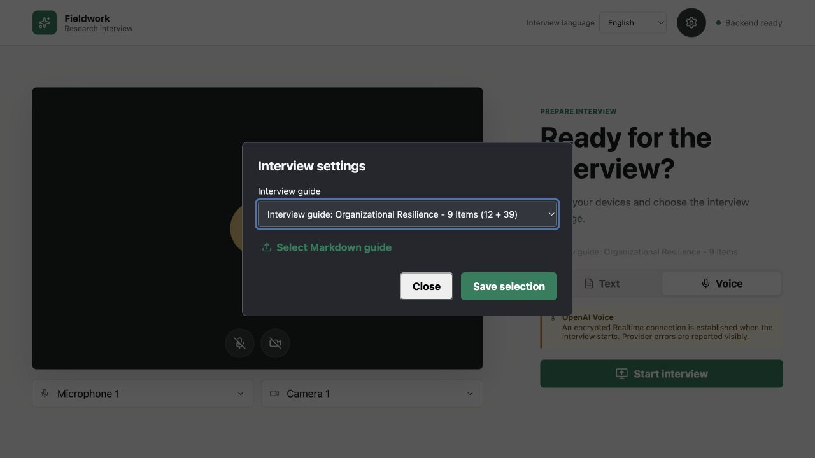
Figure 4: Interview Guide Selection. Interview settings with guide selection, Markdown upload and an explicit Save selection action.

Starting and Conducting an Interview
Start interview opens the meeting view. The central tile identifies the AI interviewer, while the self-view remains separate. Visible states distinguish listening, processing and speaking. The lower control bar provides device controls, captions, the transcript panel, pause or resume, and end.
In Text mode, send the response through the text input. In Voice mode, wait until the interface indicates that the AI is listening. Speech is transcribed live. A partial caption is not yet a confirmed transcript turn or evaluation evidence. Only the final participant transcription is stored as a canonical turn. The application blocks microphone capture during planning and AI output: the conversation operates in half-duplex mode. Figure 5 and Figure 6 show the Text and Voice meeting views.
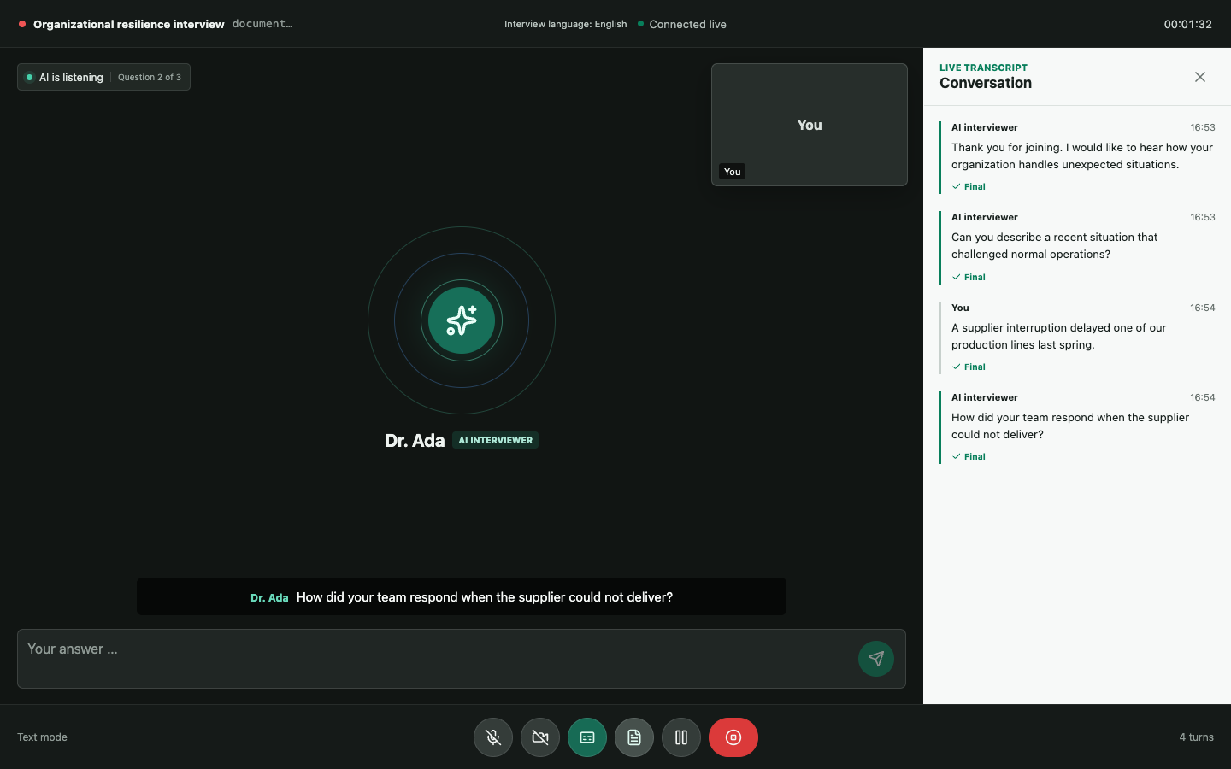
Figure 5: Interview Meeting in Text Mode. Illustrative English meeting view with synthetic dialogue, the AI interviewer and the response input.

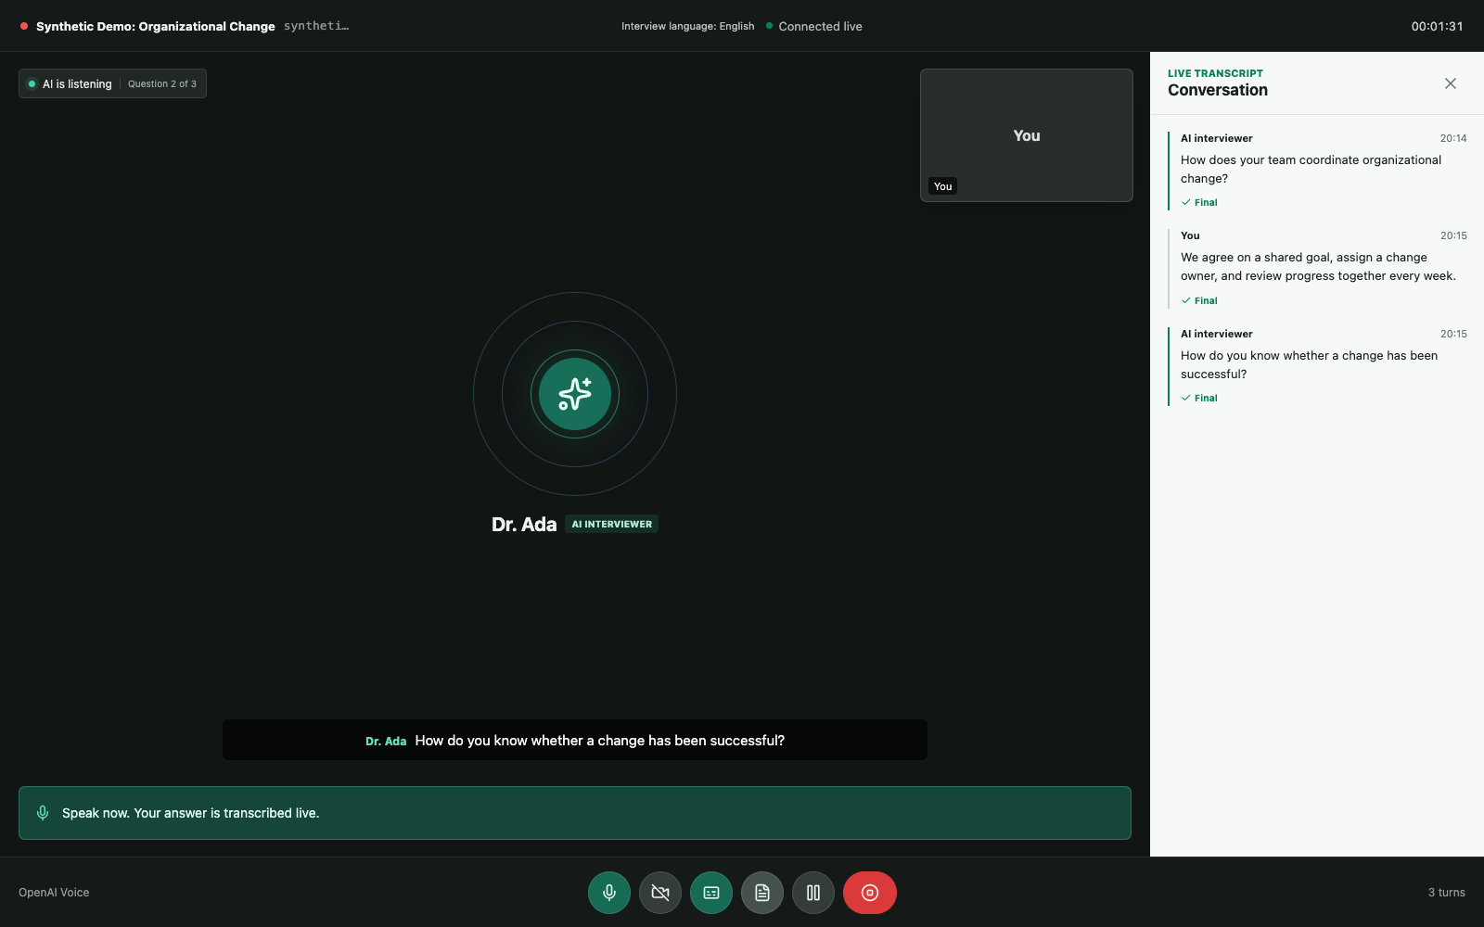
Figure 6: Interview Meeting in Voice Mode. English meeting view with active microphone, captions and transcript. Synthetic dialogue and simulated connection.
In addition to predefined refining questions, the Voice Agent can ask a limited number of specific clarification questions. For an unclear response, a clarification should identify a missing aspect, such as responsibility or a sequence of actions. A freely generated clarification is distinct from a refining question already listed in the guide. The server validates the planning proposal against the current question and interview state. This capability does not require an additional free question after every response.
Open the side panel using the transcript icon. Check speakers, order and confirmed text. Keep marked interruptions and technical gaps visible rather than replacing them with plausible assumptions. After confirmed completion and successful finalization, the Interview application can export the canonical conversation as Markdown, JSON or plain text. These downloads remain disabled while finalization is pending. Exporting does not automatically start an evaluation. Evaluation Studio's separate transcript download can also export the saved transcript of an incomplete interview.
The test in section 5.8 describes how we verified that the Voice Agent can generate clarifying follow-up questions.

Monitoring during Interviews
Open Monitoring in a second tab and select the same interview. Use the interview ID for reliable matching, because similar display names are not sufficient. The overview shows interview status and the guide. Further sections display canonical turns, partial live transcriptions, workflow steps, agent runs, question coverage and persisted events.
Agent details show structured inputs and outputs, explicit short rationales, run metadata and source references. Private internal model reasoning is not displayed. The visible processing steps depend on the operating mode: the Realtime voice path does not run the same Coverage and Consistency text workflow after every utterance.
After a connection interruption, stored events are replayed using their sequence numbers. The interface observes the process rather than changing running decisions. A read-only interface is not itself an implemented user-role or authentication boundary. Figure 7 shows the paused synthetic interview's identifier, confirmed turns and stored workflow metadata. Figure 8 separates answered and open guide questions from potential contradictions.
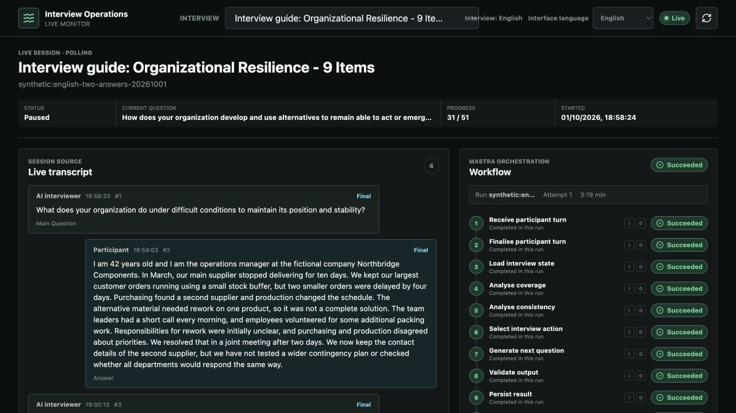
Figure 7: Monitoring Overview. Monitoring of the paused English synthetic interview, showing its identifier, confirmed turns and stored workflow metadata.
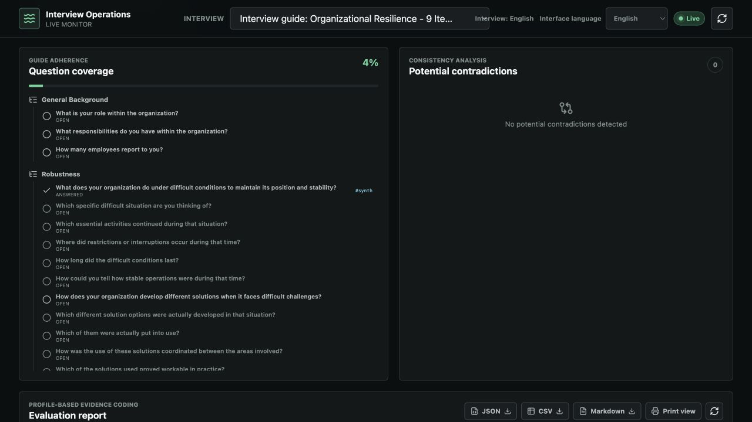
Figure 8: Question Coverage. Question coverage separates answered and open questions in the English guide. Potential contradictions are displayed in a separate panel.

Evaluating with the Evaluation Studio

Evaluate an Existing Interview in Evaluation Studio
Evaluation Studio opens with the interview list and evaluation results. Select a dataset under Interviews with answers and check the selected evaluation profile using the profile icon in the upper-right corner. The default profile is available, but it is not necessarily suitable for every research question. Profile files can be imported separately as JSON or Excel, as described under profile customization. This does not import a transcript. Uploading supplementary documents to extend the interview or evaluation context is a planned feature, not a current option. It is separate from guide upload and profile import.
Start evaluation explicitly starts a provider run. Opening or reading an interview does not generate a new evaluation. Save or discard profile changes before starting. An unsaved local draft is not silently used as a research instrument. Figure 9 shows that Start evaluation is a separate action after interview and profile selection.
An active, paused or prematurely ended interview can be evaluated once it contains confirmed interviewer and participant turns. Evaluation of the transcript so far identifies this source. The run creates a fixed snapshot of the confirmed turns and does not end the interview. Responses recorded later are not added retrospectively to that result. Explicitly start a new evaluation after resuming the interview if more data should be included. Figure 10 identifies the paused interview as an incomplete source with two responses and an existing report (see test in section 5.10). Service tests cover active, paused, ending, failed and completed interviews containing confirmed turns.
The run displays its status. A provider failure appears as an error with an error code, not as an empty successful result. Retry is available only for failed runs explicitly marked as retryable. Run again creates a new evaluation, while Refresh result loads the stored result without a new model call. A new evaluation replaces the stored result for the same interview and profile. The system does not retain a complete history of earlier reports. Export a report before running again if it is needed for comparison.
With the tests in section 5.9 and 5.11 we show that the MAS is consistent and can provide
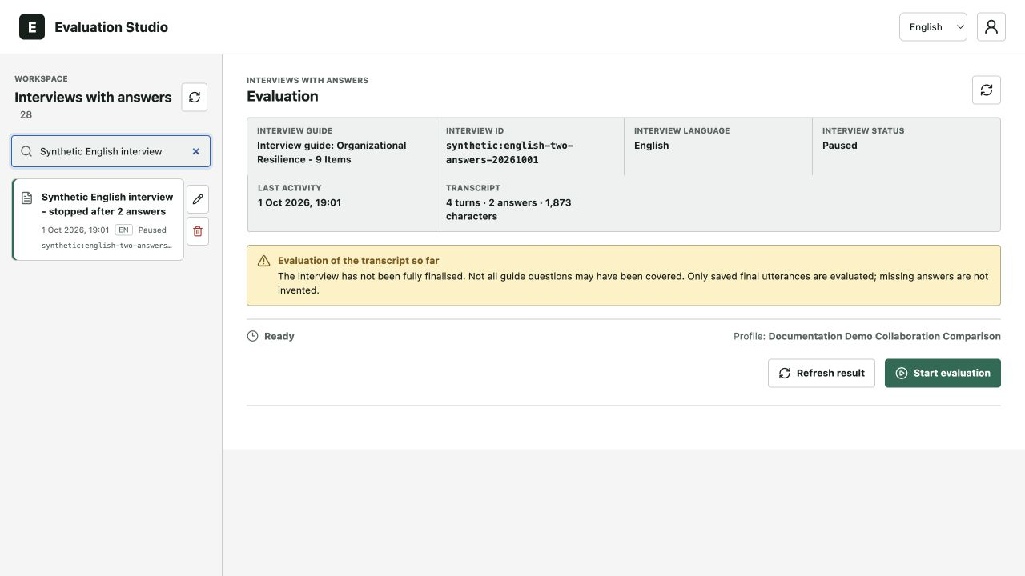
Figure 9: Starting an Evaluation. The Start evaluation action is available for the English synthetic interview with an example profile selected. Selecting the interview alone does not start a run.

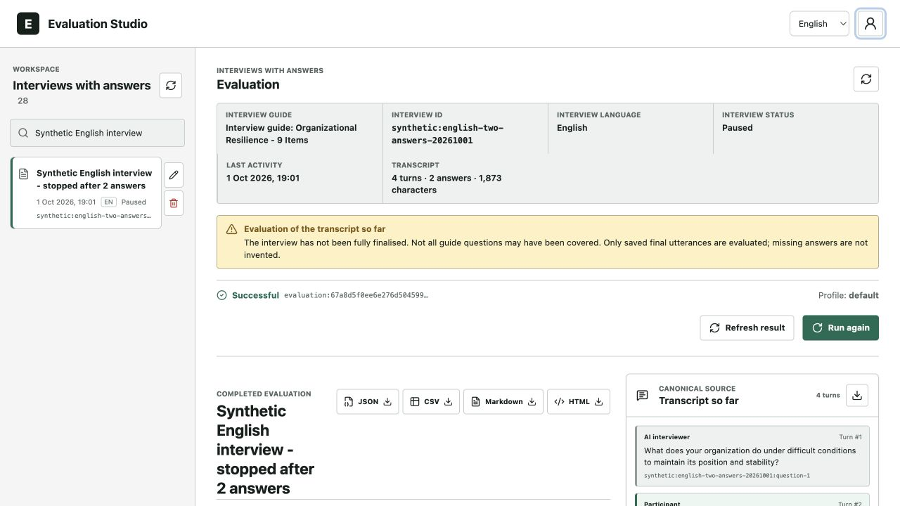
Figure 10: Evaluation of an Incomplete Interview. The paused English synthetic interview contains two responses and an existing report. The source notice identifies evaluation of the transcript recorded so far.

Viewing Results, Evidence and Exports
The report contains the overall result, the number of scored items, dimension means and item-level results. The server applies the saved profile calculation: a weighted mean or a custom formula. Calculation audit shows the configuration and actual contributions or references. Unscored items remain unscored and are not negative findings. Weighted means exclude them, while formulas substitute missing references with zero. Read an overall result together with its calculation mode and the number and status of underlying items.
Open an item and review its coding instruction, applied anchor, rationale, supporting evidence and counter-evidence. Every integer score from 1 to 7 is possible. For a scored item, expand the complete seven-anchor scale. Items marked as insufficient evidence, not applicable or conflicting evidence have no numeric score. A formula may use a zero substitution for such a reference without applying an anchor or changing the item status. Figure 11 places item agi-01, its rationale, score and model confidence beside the canonical source.
Supporting evidence and counter-evidence can each contain multiple citations. One citation can link additional source turns. Original quotations are retained. Where present, an explicit inference explains their relationship to the item. The interface labels all these citations as Evidence rather than separating direct and indirect classes. A short inference is not hidden chain-of-thought. Clicking a turn reference opens the canonical text passage. Source validation protects quotation fidelity but does not establish that an interpretation is semantically correct. Figure 12 shows supporting evidence and counter-evidence, including two references to Turn 4.
Age and position fields are visible in the report. Values are drawn only from explicit statements supported by source evidence. Otherwise, the interface reports that the information was not recorded, not stated or unclear. An unstated age must not be estimated. Model confidence is the model's self-assessment, not a statistically calibrated probability or confidence interval.
Download the report as JSON, CSV, Markdown or HTML. All formats include the saved overall result, calculation mode, weights, expression and calculation trace alongside coded items and evidence. Download transcript as Markdown exports the interview separately from its evaluation. JSON supports structured downstream processing, while Markdown and HTML support subject-matter review. Native PDF and Word report exports are not implemented in this version. They are possible later extensions. Quotations from an English source remain in their original wording when the interface language changes. Figure 13 records the run ID, model, prompt version and profile and transcript fingerprints, identifying the report's inputs and processing configuration. Figure 14 separates report export controls from the transcript download and retains the incomplete-source notice.
Throughout the development of the MAS the wording and presentation have been adjusted to improve comprehension and consistency throughout all interfaces and reports. Details can be found in the corresponding tests/changes (e.g. section 5.9 and 5.11).
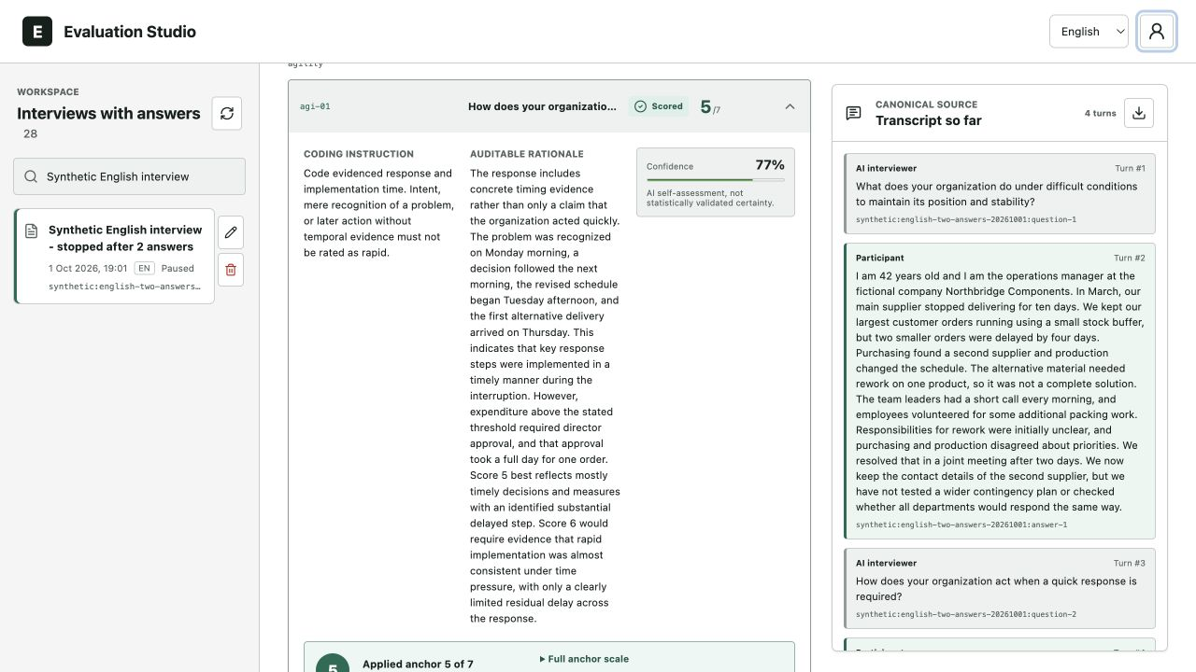
Figure 11: Item Score and Rationale. Expanded item agi-01 in the existing synthetic report, with its coding instruction, detailed rationale, score and model confidence beside the canonical source.
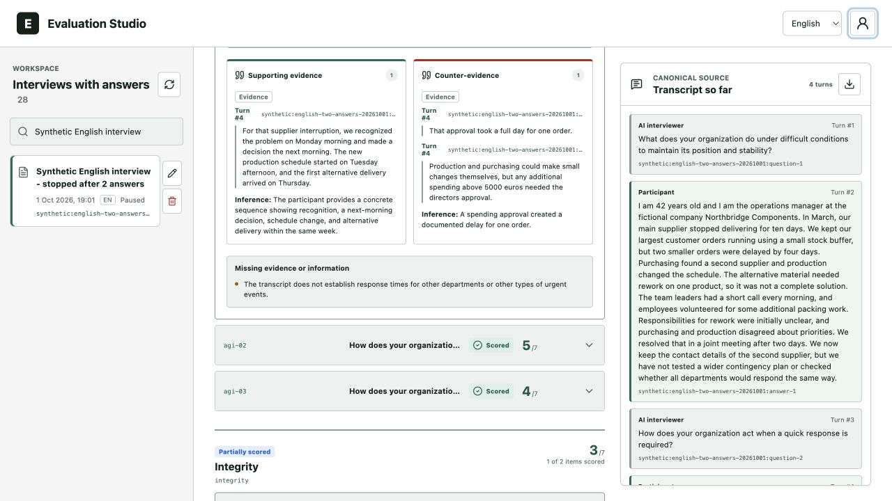
Figure 12: Supporting Evidence and Counter Evidence. Supporting evidence and counter-evidence for the same item, with original quotations and an explicit inference. The counter-evidence links two passages from Turn 4.
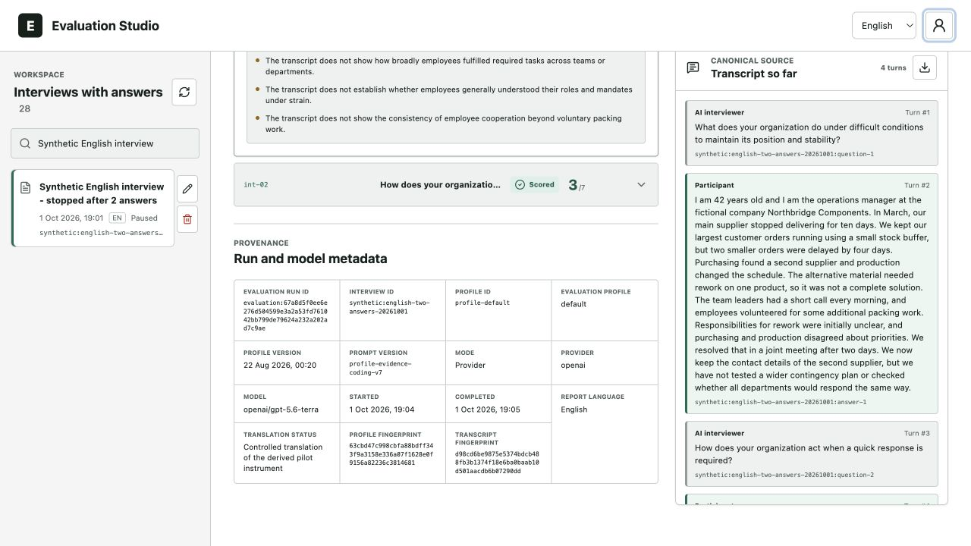
Figure 13: Report Provenance. Provenance of the stored report, including the run ID, model, prompt version, and profile and transcript fingerprints.
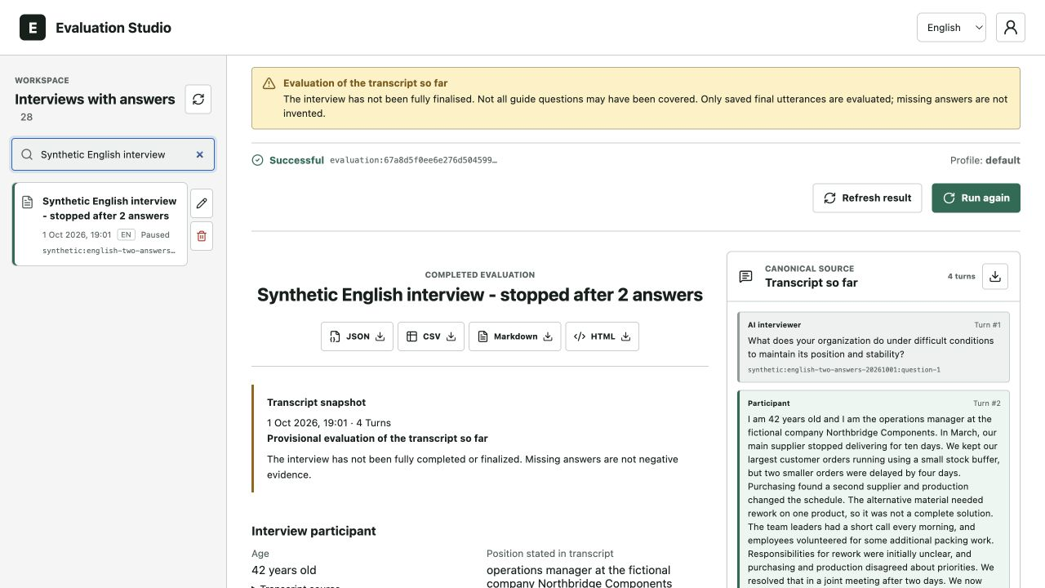
Figure 14: Report and Transcript Exports. Report export controls for JSON, CSV, Markdown and HTML, alongside the separate transcript download. The incomplete-source notice remains visible.

Changes, Options and Customizations of the MAS
The interview guide determines which questions are asked. The evaluation profile determines how confirmed answers are coded. The following settings let researchers edit the profile, configure the overall calculation, import profile files and manage stored interviews. Changing a profile does not change the guide used during an interview.

Select Edit and Create Profiles for Other Research Topics
The person icon in the upper-right corner opens the Evaluation profile. Search the stored profiles, select one for evaluation, choose Manage profile to edit it, or New profile to create a draft. The icon represents an evaluation profile, not a personal account. The application has no login system. Figure 15 shows the profile menu and the separate actions for managing an existing profile or creating a draft.
Profile management allows changes to the profile name, description and subject-matter coder prompt. Under Dimensions and items, add dimensions and assign items. An item has a stable ID, a label, a coding instruction and seven anchor criteria. Dimensions and items can be reordered. Save persists a valid draft, while Discard removes unsaved changes. A version conflict identifies concurrent editing rather than silently overwriting it. The default profile is editable and duplicable but cannot be deleted. Duplicate profile creates a separate starting point for another topic without rewriting the default instrument.
The draft in Figure 16, Documentation Demo Team Collaboration, uses the dimension Collaboration and the item Information Exchange. Its prompt, coding instruction and seven criteria describe another research topic. Additional dimensions can be added because the generic profile contract does not hard-code Robustness, Agility and Integrity. The item scale stays fixed from 1 to 7, while downstream weights and the overall calculation can be configured independently. The New profile heading and Unsaved status identify a draft that has not yet been saved. Figure 17 shows the seven editable Information Exchange anchor criteria in the Collaboration dimension.
Profiles are not tied to a particular guide or language and require no guide ID. An appropriate guide must still collect the required evidence. Selecting a profile cannot create missing statements. Custom profiles are not automatically translated. The English overlay for the unchanged default instrument is a separate controlled mechanism, not a general translation of subject-matter profile content.
API keys, model selection, the voice and the evaluation timeout are configured on the server through the .env file. They cannot be changed in the profile editor. Applying a change requires recreating the backend container. The relevant settings are OPENAI_API_KEY, OPENAI_REALTIME_MODEL, INTERVIEW_AGENT_MODEL, EVALUATION_MODEL, OPENAI_REALTIME_VOICE and EVALUATION_TIMEOUT_MS. Figure 18 shows editable profile fields beside read-only technical information.
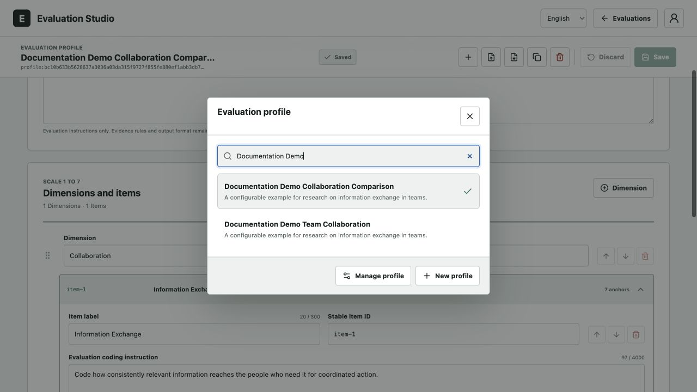
Figure 15: Evaluation Profile Menu. English profile menu with two example profiles and controls to manage an existing profile or create a new one.

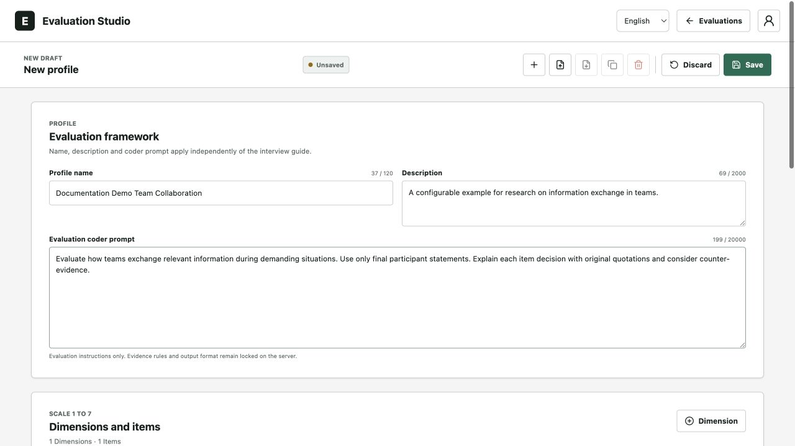
Figure 16: New Profile Draft. Unsaved English profile draft with an editable name, description and independent research coder prompt.
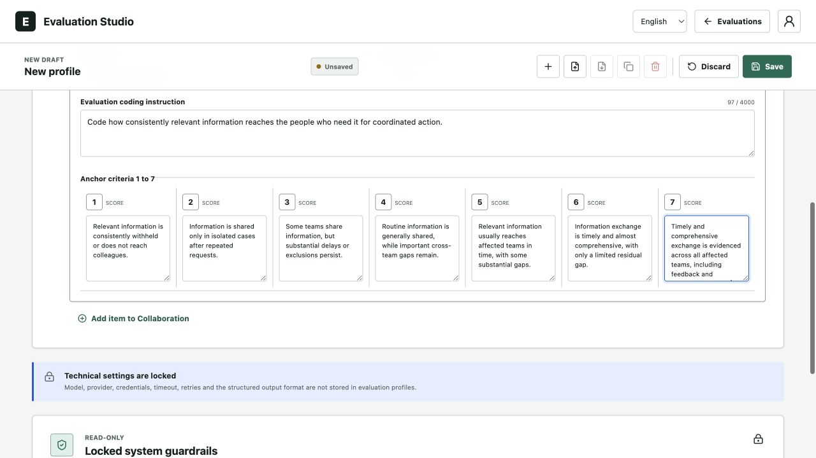
Figure 17: Seven Anchor Criteria. Seven editable anchor criteria for Information Exchange in the Collaboration dimension, illustrating configuration for another research topic.
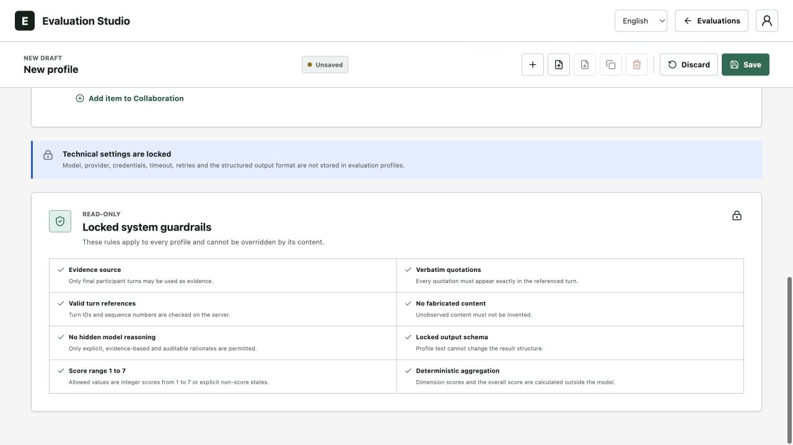
Figure 18: The profile editor separates read-only technical information from editable subject-matter fields. Runtime values are configured on the server through .env.

Configure Aggregation Weights and the Overall Calculation
Calculation settings change how coded item values contribute to a dimension and the overall result. This section describes how such aggregation rules can be set.
Open the profile menu and choose Manage profile. Dimension and item weight fields appear beside their corresponding records with a default value of one. Use any finite non-negative number, not necessarily a percentage. In weighted mode, a weight of zero excludes that contribution. Save persists the configuration for subsequent evaluations. Discard restores the stored draft and clears local preview state. Changing a weight does not rewrite an existing report or start an evaluation. Figure 19 locates the independent dimension and item weights in the profile editor.
In Calculation, select Weighted mean and open Local test preview. Enter integer test scores from 1 to 7 or leave a field empty. The example assigns 6 to Reliable delivery, no score to Contingency coverage, and 2 to Learning from incidents. Effective weights of 6 and 1 produce (6 × 6 + 2 × 1) / 7 = 5.43. The missing item contributes neither to the numerator nor the denominator. These predefined values demonstrate calculation only and are not AI judgments. Figure 20 shows the resulting local preview with a result of 5.43 out of 7 and the missing item excluded.
Select Formula to enter a mathematical expression. The reference selectors insert stable IDs at the cursor. Renaming or removing a referenced item does not silently rewrite the expression: fix the invalid reference before saving. The example (item("delivery-1") + item("delivery-2")) / 2 * 10 uses 6 and a zero substitution, so the overall result is 30. The overall result is not displayed as a score out of 7, and Contingency coverage remains unscored. Preview values are local test inputs and are not saved as transcript evidence. Figure 21 shows stable-ID insertion and a local formula result of 30, with zero substituted only inside the expression.
After an explicitly requested evaluation, the overall result replaces the former mean. Calculation audit expands the saved configuration, dimension values and actual formula references. Zero substituted distinguishes a missing source value from an observed numeric zero. Weighted reports show effective coefficients and excluded contributions. Formula reports omit /7 on the overall result while dimension and item values keep their original scale. A calculation error remains visible even with the audit collapsed. Item scores, quotations and missing-information notes remain available.
The report in Figure 22 uses the same existing synthetic English transcript and predefined demonstration scores without invoking a provider. Its Demo provenance and explanatory rationale distinguish this arithmetic check from an AI assessment. The temporary profiles and their demonstration runs were removed after screenshots and export verification without changing existing research records (see section 5.10 for initial testing).

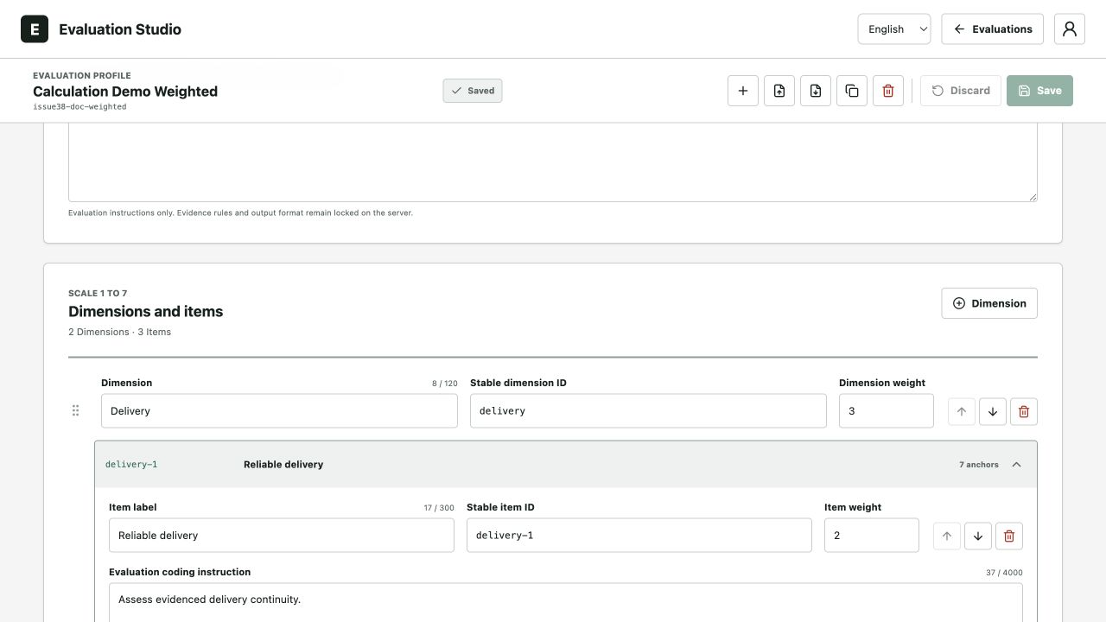
Figure 19: Dimension and Item Weights. English profile editor showing independent dimension and item weights in the temporary Calculation Demo Weighted profile. These settings are independent of the interview guide.

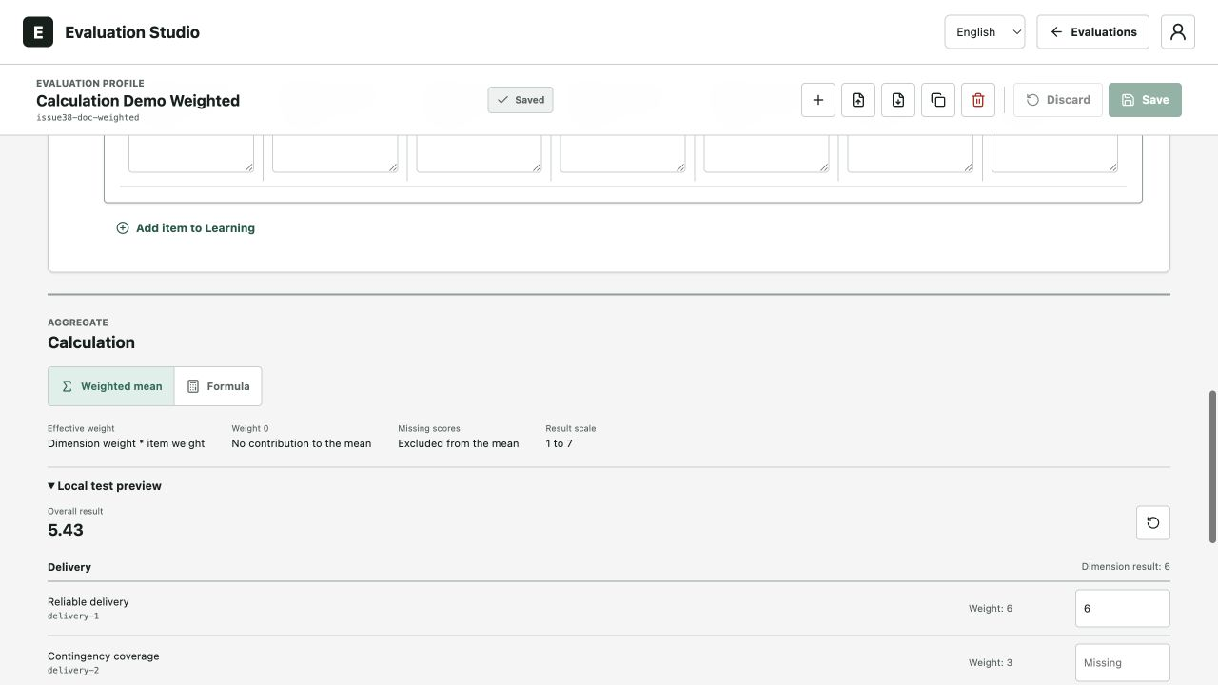
Figure 20: Weighted Mean Preview. Local weighted preview with predefined scores 6, missing and 2. The result is 5.43 out of 7. The empty item is excluded and remaining effective weights are normalized.
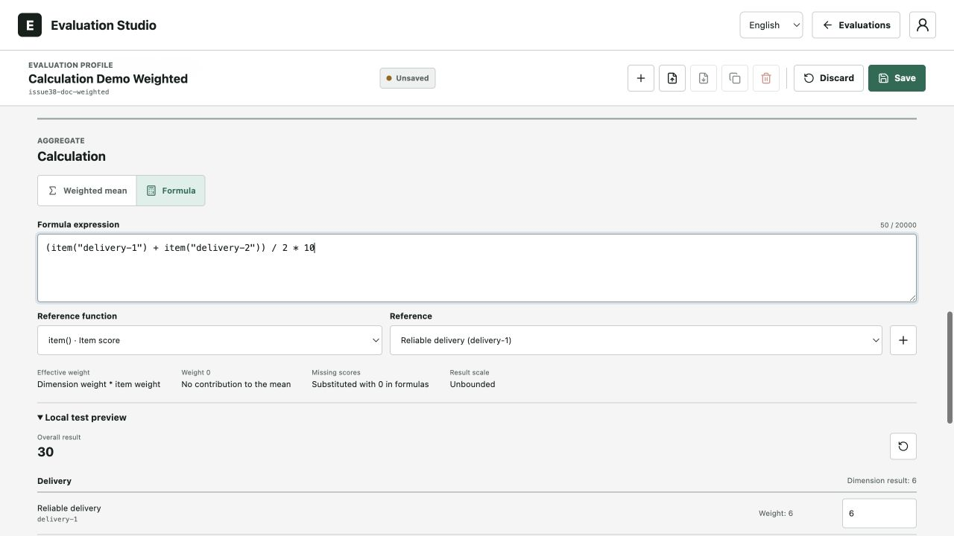
Figure 21: Formula Editor and Preview. English formula editor with ID insertion, an unrestricted result scale and a local result of 30. The missing item is substituted with zero inside this expression only.
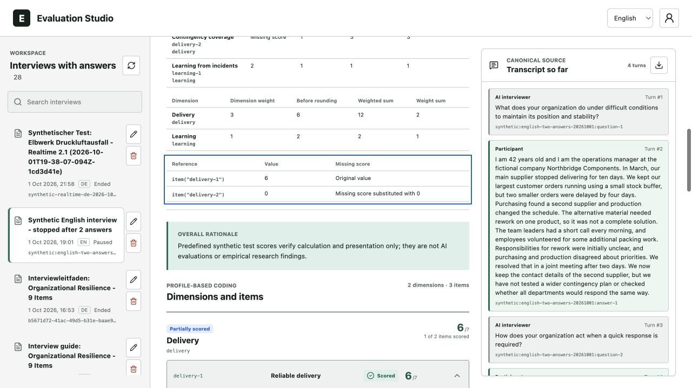
Figure 22: Formula Calculation Audit. Saved synthetic formula report showing the calculation references: delivery-1 uses its original value of 6, while missing delivery-2 is substituted with 0. The original transcript remains visible alongside the audit. No provider evaluation was run.

JSON and Excel Import and Studio Language Selection
JSON and Excel are alternative file formats for the same evaluation profile. To import a profile, choose Import profile and select a file in either format. If you need a starting point, download the generic version 2 template. In Excel, the sheets Instructions, Profile, Dimensions, Items and Anchors contain the profile settings. Formula expressions are stored as text, not as executable Excel formulas. JSON stores the same settings. Version 1 files can also be imported and use the default weighted mean. The server checks the file and shows a preview before saving. Review the preview, then choose Confirm import to save the profile. Figure 23 shows the import dialog, template download and replacement target. Confirm import remains unavailable until validation succeeds.
Choose As a new profile to retain the profile ID supplied in the file. If that ID already exists, the import reports a conflict. Replace selected profile deliberately overwrites the selected profile and should not target the default profile for demonstrations. Invalid IDs, missing anchors, negative or non-finite weights, unknown formula references and unsupported active Excel content produce errors rather than fabricated repairs. JSON export preserves the full configuration, including weights and the mathematical expression.
The Studio language control changes the interface independently of an interview's fixed language. It does not regenerate an existing report or its original quotations. Coder-generated rationales follow the evaluation context. Changing the interface alone is neither a translation request nor a scoring call. An English interface can therefore display original report text or quotations in another language. Figure 24 shows the English interface with an applied anchor and the source's unchanged quotations.
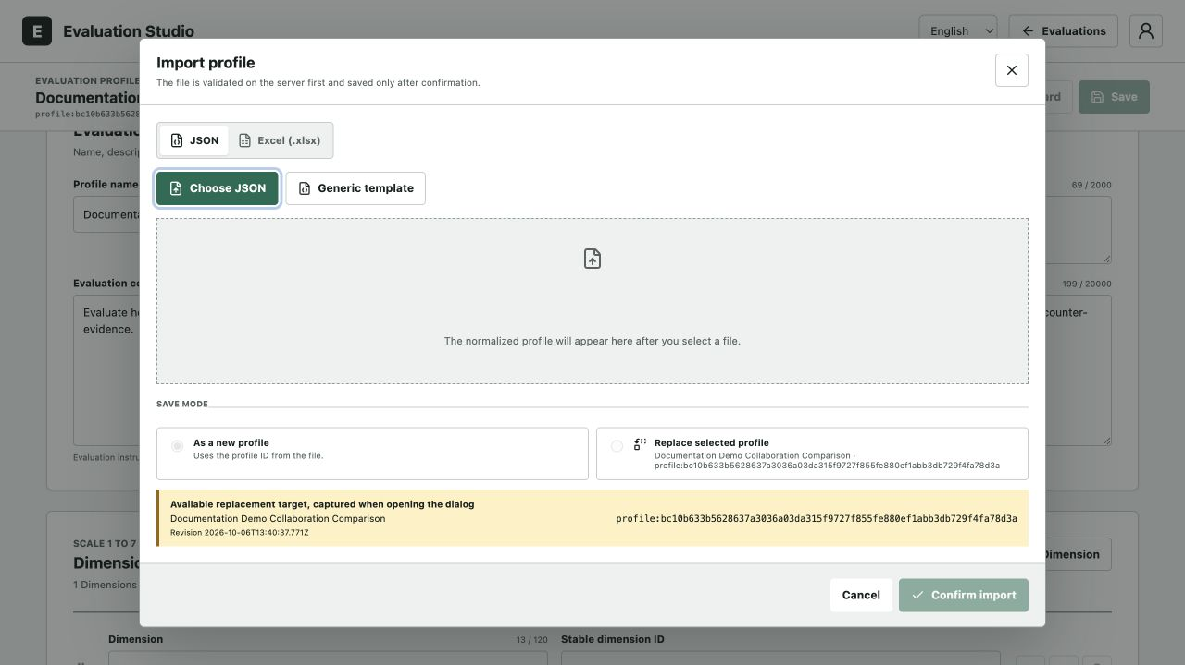
Figure 23: Profile Import Dialog. Profile import dialog with JSON and Excel options, a generic template and a fixed replacement target. Confirm import is disabled before a valid file is selected.
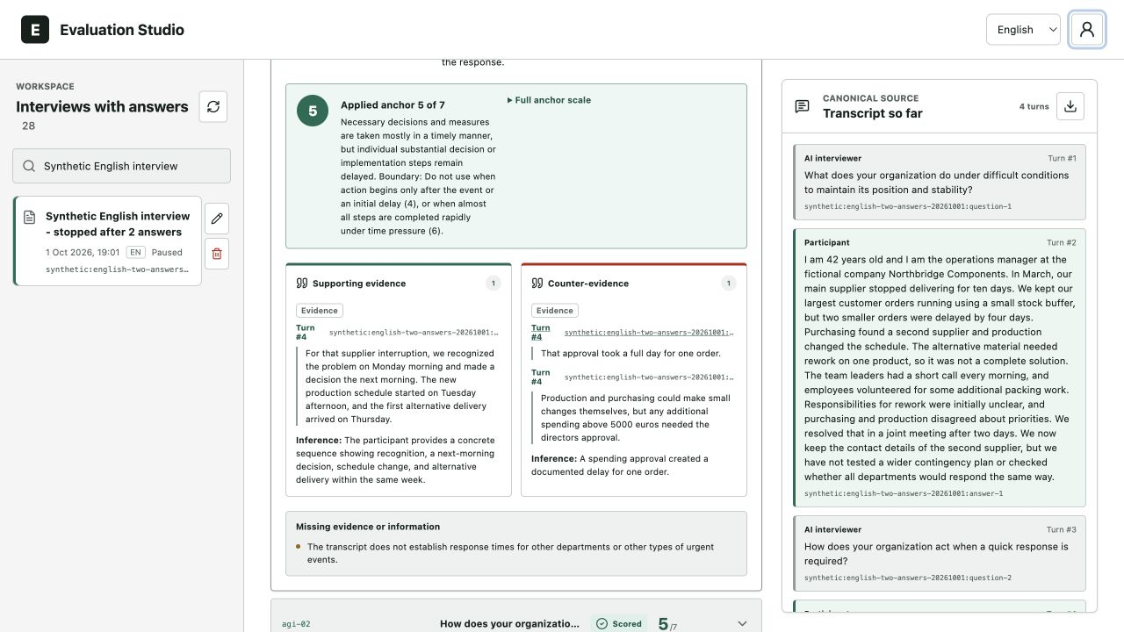
Figure 24: English Evaluation Studio. English Evaluation Studio displaying an applied anchor and unchanged quotations from the English transcript. Viewing the stored result does not trigger another evaluation.

Manage Interview Datasets
The interview list provides rename and delete actions. A display-name change does not alter the internal interview ID or create new evidence. Deletion removes interview-related data atomically and requires explicit confirmation. An active interview, running job or ongoing evaluation can prevent deletion.
For comparative analyses, export the report and transcript before deletion and retain the profile version used. A screenshot of the overall score alone is not a sufficient traceable data record.

Verification Pilot Findings and Interpretation Limits
This chapter summarizes what the technical checks and synthetic runs demonstrate. It also separates those results from questions of research validity that require empirical evidence.

Types of Technical Evidence
An automated software test supplies an example input and compares the result with an expected outcome. For example, a transcript export test checks that the downloaded conversation retains the stored words and speaker order. Software verification uses such checks to establish whether an implementation meets its stated requirements. Passing the selected checks provides evidence about those requirements, while other faults may remain (Bourque et al., 2014).
Tests examine different parts of the application. A unit test checks one small function, such as reading a question heading. An integration test checks connected parts, such as saving an answer and retrieving it from the database. A regression test repeats existing checks after a software change to detect whether previously working behavior has broken (Bourque et al., 2014). The database tests use a real, separately configured database.
Synthetic pilot runs use fictional interview material to exercise a longer process. In the Realtime pilot, a simulated participant supplied fixed text answers while the interviewer generated speech. In the scoring pilot, the same transcript was evaluated repeatedly to examine how much scores, quotations and explanations changed. Repeated evaluations are one way to examine the consistency of an LLM evaluator under fixed conditions (Lee et al., 2025).
Consistency and validity answer different questions. Consistency concerns whether repeated evaluations of the same material produce similar results. Construct validity concerns whether a score can be interpreted as a measure of the intended characteristic, such as organizational resilience. Stable scores alone do not establish that interpretation. Evidence linking the scores to the proposed construct is also needed (Cronbach & Meehl, 1955).
Table 2 brings the recorded checks and pilots together. Its first column identifies the check, the second gives the observed result, and the last explains what that result supports and where its scope ends. The counts describe software checks and individual pilot runs.
Table 2: Recorded software checks and pilot runs with their interpretation limits.
Test or pilot | Recorded Result | Meaning and limitations
Automated regression tests | 1,403 tests passed; 57 PostgreSQL tests skipped in the regular run; lint and type checks passed | The defined software checks passed. This supports the tested functions, but does not establish that every possible error has been found.
Separate database tests | All 57 tests passed against an isolated PostgreSQL 18 database | Saving and database rules were checked on PostgreSQL 18. The deployed application uses PostgreSQL 17.9.
Synthetic Realtime interview | 84 canonical turns, 43 audio outputs, 41 participant responses, one freely generated clarification, no technical gaps | Demonstrates this simulated conversation and audio generation. Microphone input, speech recognition, automatic turn detection and browser playback were not tested. No scoring was run.
Repeated scoring of one synthetic interview | Ten successful evaluations; eleven model calls; overall scores from 4.78 to 4.89; eight of nine items identical throughout | Shows limited variation for one interview using prompt v4. The coder now uses v7. This pilot does not establish the validity of the scale.

Software and Persistence Verification
In the documented regular regression run, 1,403 tests passed. The 57 database tests were skipped in that run because they require a separately configured test database. A skipped test has not produced a pass or fail result. A separate run recorded all 57 database tests passing against a disposable PostgreSQL 18 instance. They are not included in the 1,403 passing tests. Lint and type checks also passed. These inspect code for specified programming problems and incompatible data types.
The checks cover guide processing, transcript order, source references, storage and exports. They also check that receiving the same message twice does not create duplicate transcript entries, a property called idempotency. Source validation checks whether a quotation refers to a permitted interview statement. Database tests check that stored information can be retrieved unchanged, that simultaneous requests are handled, and that groups of changes succeed or fail together. Interview-management checks cover renaming and deletion, including conflicts with an ongoing evaluation.
Database migrations are ordered instructions that prepare or update the stored data structure. The application contains 18 SQL migration files, numbered 0000 through 0017. Its readiness check separately expects application schema version 15. The migration-file count and the readiness version are different internal counts. The normal Docker deployment uses PostgreSQL 17.9, while the separate database tests use PostgreSQL 18.

Tests and Changes
This chapter traces the main tests and changes in chronological order, from anchor validation through interview behavior to scoring consistency. It describes what was tried, what was observed and how the implementation changed.

Test/Change: Validation of Anchoring Values
We derived the anchoring values from a variety from different empirical studies published on the topic of organizational resilience. We used GenAI (ChatGPT) to extracted relevant passages form their results section to derive a generalized anchoring statement based on the passage. Additionally the AI provided typical evidence and an explanation why this anchoring value fits, for the specific item and Likert value. The GenAI was provided the relevant passage containing empirical evidence and the items. In the beginning the GenAI was prompted with information regarding the construction of anchoring values. Every output was screened and checked by the authors before been included in the anchoring values list.
We derived at least two anchoring values for each item, sometimes if we come across more suitable items more. In our final sample we derived 70 anchoring values.
To validate these derived values were translated into a survey, by creating a question for each item at a given likert value and each anchoring example. We asked the same question for each item: “Is this example suitable for representing the statement at the specified scale point?”. Then we provided the following information: e.g.
Statement: My organization stands straight and preserves its position.
Scale Point: 7 (totally agree)
Example: The organization can maintain its position and stability even under severe crisis conditions.
As answer options there was a “Yes” and a “No” option with the no option requiring the participant to provide a better example for an anchoring value.

Test/Change: Testing the reasoning model
We wanted to develop a voice agent that could generate its own follow-up questions to improve data quality and make interviews more thorough. To achieve this, we iteratively adjusted the reasoning and question-planning process, starting with the model configuration and eventually changing how the interview workflow was handled.
Originally, interview responses were processed by a separate analysis pipeline orchestrated with Mastra. Its purpose was to identify which questions had already been answered and prepare the next contribution to the interview. The default model for this process was openai/gpt-5.6-terra. However, the additional model calls increased the processing time between an interviewee's response and the next question.
As a first step, we separated the model configurations for ongoing interview analysis and post-interview evaluation. We changed the Voie Agent to openai/gpt-5.4-nano to speed up the analysis performed during the interview, while keeping the Scoring Agent set to openai/gpt-5.6-terra for the subsequent transcript evaluation. The backend reads these settings at startup and passes the configured models to the corresponding Mastra components. This change was therefore implemented through the server-side configuration rather than by replacing an internal reasoning submodel of the voice model.
We then optimized the workflow itself. Some analysis steps could be executed in parallel, while decisions that could be made using fixed rules no longer required a separate model call. Finally, we moved question planning into the ongoing gpt-realtime-2.1 voice session. The voice model now proposes the next conversational step in a structured format, which the backend validates against the interview guide and the current interview state before allowing the spoken response to proceed. This avoids having to run the separate analysis process after every spoken answer.
We tested the different configurations through repeated test interviews. The results highlighted an important trade-off: more sophisticated reasoning models tended to generate better follow-up questions, but they also took substantially longer to process the interview data and formulate their responses. Even a delay of around 10 seconds can feel like an eternity to an interviewee and disrupt the natural flow of a conversation.
Consequently, our goal was not simply to maximize the quality of the generated questions, but to find the optimal balance between interview experience and output quality. Since the external reasoning models we tested required at least 10 seconds to generate a follow-up question, we decided to retain the integrated reasoning and question-planning capabilities of gpt-realtime-2.1 for the live interview. This approach prioritizes conversational continuity and avoids awkward pauses, while keeping the more sophisticated model openai/gpt-5.6-terra available for the separate, post-interview evaluation.
The resulting default configuration is gpt-realtime-2.1 for voice interactions, openai/gpt-5.4-nano for ongoing text analysis, and openai/gpt-5.6-terra for evaluation.

Test/Change: First Validation of the Voice Agent & Scoring Agent
We want to test the Scoring Agent of the MAS. In doing this we want to check if the Agent can identify the “correct” and important phrases and derive the “correct” score for them. To test this we generated two test scripts that are based on the anchoring values. By doing this as first test we are sure that there is a correct value we can look for, we know that the MAS should know the key words and we can double check the output and reasoning. The first script is based on the anchoring examples for the Likert value 7 of each item. We provided the example sentences to ChatGPT and generated corresponding answers an interviewee could give during an interview. We also asked the ChatGPT to generate additional demographic information. The second script was generated the same way, just using a mix of different likert value examples (acerage score of 4,33; included at least 2 times each likert value).
This scripts were after generation double checked and separately provided to the scoring agent. For the script with all 7 values, the MAS derived the correct overall value and logically the correct item values. It managed to extract the most relevant passages, yet sometimes could have extracted passages providing indirect proof.
In test with the mixed values the MAS derived the correct overall value but failed to correctly score each item. There were 4 deviations (2 x robustness, 2x integrity) where the scoring was to high/low. After checking for the most relevant passages we discovered that they were correctly identified, yet again indirect proof was not mentioned. Reading through the transcript again we acknowledged that the passages and phrases included in the transcript were not extreme enough to actually be the extreme value (1 or 7) and a 2-3 or 5-6 would be more appropriate. Therefore the MAS was on the right track not scoring like we expected, but should have moved towards the extremes.
Overall did the MAS find all relevant Aspects and the scoring was mostly accurate. One problem we encountered was that the scoring was only 4s and 7s yet not other numbers. The provided explanation was helpful. This and the lack of referencing indirect evidence will be addressed in an upcoming test, were we plan on creating another script without basing the content on the anchoring values.
This said, this test was in the sense successful as we could confirm that the scoring agent can derive correct/accurate scores and reference the important sections. Future tests should now test it with a real interview and “random” values. The only problem we then face is how to determine the correct value for each item.
One final remark: In this case it is easily controllable if the value provided by the MAS is “correct”. For a real life scenario, a value from the MAS could be different from the questionnaire as one can’t know whether the questionnaire or the MAS is actually correct as both can only try to provide an accurate estimate.
After the first test we discovered that rephrasing our questions we ask during our interview may help us to derive more relevant information that is focused on the topic we want to explore. This also allows us to derive follow up questions beforehand we can provide the MAS as inspiration to increase the depth of information collection.

Test/Change: Second Validation of the Voice Agent & Scoring Agent
In this test we wanted to check whether the MAS can detect relevant passages even when they aren’t included in the anchoring values. While doing this we can do more testing on the scoring agent. First we did a test where values are the same across all items. We generated two interview transcript with ChatGPT one only providing answers equivalent to value 1 and one to value 7. Both tests resulted in the MAS identifying all relevant passages and deriving the “correct” value for each item. The MAS also was able to derive other values than 4 and 7 (here value 1).
With this test we implemented an backend improvement that compacts the context. We included this change as preemptive measure to prevent context loss and to high computing requirements during long interviews or large date uploads. To check if this change had any impact is difficult, as we didn’t have any problems with context being lost or information overload shutting the whole system down. We plan on doing a test in the future during which we provide the MAS a lot of information (long interview and additional data) which could potentially reach limitations (such a test is planned for a later date).

Test/Change: Rework of the Questionnaire
Following our previous tests we noticed difficulties with the open questions in our questionnaire. The allowed for answers to be too vague and unrelated, bearing the potential to get of script and providing for the evaluation unusual information. This is why we thought about reframing the questions to be more focused on the topics of interest by making them more precise. To still allow for more details and a nuanced understanding, we developed refining questions the MAS should ask as a follow-up to a main question. This helps save computing power, yet still allows the use of the build in reasoning model instead of an external model. This is also in line with our previous test on the models performance and the interview quality (see test 5.2). With this change we hope to capture more relevant information and prevent interviewees from drifting off topic.
We began revising the questionnaire by providing ChatGPT with responses from previous tests, their evaluation results and the existing questionnaire. We asked it to propose more focused main questions based on the scale and several refining questions. We then checked and refined the proposed questions. We also checked that the revised main questions still addressed the intended aspects without departing too far from the originals.
We tested the reworked questionnaire by staging a new very focused interview with only short answers. This is part of test 5.6. The results show that the MAS did ask all of the refining questions (only changed the order of questions) and didn’t ask other questions. The final score was what we expected. To further test the formation of follow up questions and when the get asked, we conducted another test. (See test 5.8)

Test/Change: Multi Test 1
We had to conduct multiple test and made improvements to the output. We tested if the MAS was able to score the content beyond the three defined anchoring values (1, 4, 7), if the reworked questions are useful and if the development of follow up questions by the MAS itself was improved. We also encouraged the MAS to output more evidence to further underscore why a certain score was achieved. In addition we let the MAS shortly explain why it chose the anchoring value and not a different one.
We again let ChatGPT generate an interview which we used as guideline to help stay on topic and deliver relevant paragraphs. One of the authors conducted a verbal interview with the Voice Agent. During this interview no problems occurred. The MAS guided the interviewee, asked refining questions and scored the final result. We had the interviewee purposely answer very shortly to each question to provoke the Voice Agent to ask refining/follow up questions. The MAS asked all refining questions, no follow up questions and derived a score with values different from 1, 4 and 7. The final score was in line with our expectations. All relevant passages were referenced. References from refining questions and the main question were also referenced in combination. Also the model explained shortly why it chose the anchoring value and contrasted it to the lower value and higher value.
Overall the questionnaire worked and the refining question were used by the Voice Agent. The interview didn’t have any stutters or long waiting periods. The scoring output revealed that each individual score is not bound to the values of the anchoring examples. Further, the additional evidence as well as the reasoning behind the anchoring values used enabled a better understanding of the derived score. In a future test we want to check the use of follow up questions (see test 5.8).

Test/Change: Output Improvements & Evidence Citation
In the Following we did several changes to the output format to improve the comprehensiveness of scores and cited passages to prevent a black box. These changes were implemented before and tested with test 5.8. The changes are visual or provide more data which already has been collected.
Visually we first improved the naming of output section to make them easier to understand and more in line with other names. Second we include a disclaimer in our limitations of the output to explain the meaning of the confidence score and how it should be read. (The score is an additional indicator on how confident the MAS is in not having made a mistake in valuing each item. The Score is AI generated.). Following Cash et al. (2026) it is acceptable to use such scores. Third we did several small linguistic improvements to improve overall readability and comprehensibility.
We also included explicitly stated demographic information collected at the start of each interview. Evidence can include contextual statements when they support a defensible inference, provided that the original quotation and a short explanation of that inference are retained. The item rationale explains why cited passages support the result.
Age and position are extracted only from explicit statements with original source quotations. The report distinguishes supporting evidence for an item rating from counter-evidence against it. Original quotations, additional source turns and a short explanation of an inference are retained.
Results were as expected and included all changes made. Relevant passages containing information about the demographic data were cited correctly.

Test/Change: Refining questions
For follow-up questions, we conducted a synthetic interview with the real gpt-realtime-2.1 model and the standard German interview guide. A deterministically simulated interviewee gave short text answers, including a deliberately unclear description of their responsibility. The answers were stored through the same backend path as regular interview turns. The Realtime model proposed the next question, the backend checked the proposal, and the model then generated the approved audio output. This tested the model’s response to an incomplete answer rather than playing a locally prepared question.
In response to the unclear answer, the model generated this clarification question: „Welche konkreten Aufgaben oder Entscheidungsbefugnisse gehören in dieser Rolle zu Ihrer Verantwortung?“ It asks which specific tasks or decision-making powers within that role fall under the interviewee’s responsibility. The question was not in the guide and was accepted unchanged. The stored tool output identified the missing tasks or powers. The test therefore distinguishes an answer-specific clarification from a predefined refining question or a repetition. The completed run comprised 12 main questions, 28 selected guide refining questions and one clarification question.

Test/Change: Consistency
To test the consistency of our scoring agent we want to do a repetitive evaluation with the same interview. This interview should be rather elaborate and contain vague answers. This is to check the consistency of the scoring, to check the cited passages and how they might vary and the reasoning behind the evaluation. Such a elaborate interview with sometimes vague answers also reflects a real interview situation. (We may conduct such a test again with a real interview with a more finalized version of the MAS).
We tested the consistency by creating an elaborate interview. This interview is AI generated based on a multi stage process. First we prompted the AI to create a company with an active crisis or who had a prior crisis. This company story should be elaborate and contain details. After this we transformed this story along the questionnaire to cover main aspects yet remain sometimes vague/ambivalent. Each time the previously generated company story didn’t contain information regarding a specific aspect, the MAS could add information. The revised story finally was transformed into an interview (questions and corresponding answers) which should have taken approximately 30 minutes. Also an interviewee was created and the answers were rewritten to fit the persons job, experience and insights into the company. The final interview outline was checked and situationally adapted to provide more vague and ambivalent answers.
This new interview was then used as the basis for 10 independent evaluations in the MAS. Each iteration was done separately. Each evaluation output was collected and fed to ChatGPT for an initial analysis. This analysis was set out to highlight inconsistencies during scoring, referencing and reasoning. Each output was subsequently evaluated by the authors with a focus on the AI highlighted sections.
The synthetic mass test comprises ten successful evaluations of the same input with prompt v4. Eight of the nine item values remained identical, while one item varied between 4 and 5. Overall scores ranged from 4.78 to 4.89. Quotations varied only in length, while explanations varied in wording but conveyed the same core message. This concludes that the MAS in conjunction with anchoring values can provide consistent outputs.

Test/Change: Evaluation trigger changes
During a showcase with a co-author, we discovered that the MAS would not start an evaluation until all interview questions had been answered or at least asked by the voice agent. The underlying issue was an explicit prerequisite in the backend: an evaluation could only begin once the interview had been marked as completed and its transcript finalized. Consequently, paused or prematurely terminated interviews were rejected before the scoring agent was called, even when usable responses had already been stored. The problem was therefore not the scoring agent's ability to evaluate the available answers, but the backend's requirement for a fully completed interview.
We changed this prerequisite so that an evaluation can now be initiated as soon as at least one interviewer contribution and one participant response have been saved in their final form. Completing the entire interview guide is no longer necessary. The scoring agent continues to use only the participant's statements as evidence. To ensure a consistent evaluation, the system creates a snapshot of the conversation as stored at the time of the request and excludes provisional live transcriptions. The evaluation neither terminates the interview nor changes its status to completed. Instead, it evaluates the available evidence and marks items without sufficient evidence accordingly. Under the default weighted-mean aggregation rule, only items that have actually been scored contribute to the overall score. If the interview is subsequently resumed, a new evaluation must be initiated to incorporate the additional responses.
As part of the same test, we also deployed a language update enabling the interviewer to conduct interviews in English using an English-language questionnaire. We translated the questionnaire from German into English and uploaded it in advance. To test these changes, we started a new interview in Englisch and stopped after completing all questions belonging to the first item.
The results confirmed that the MAS correctly evaluated the incomplete interview. Only the first item received a score, while all remaining items were marked as having insufficient evidence. The final score matched our expectations. This demonstrated that the system could evaluate the available responses without requiring the entire interview to be completed. The test also confirmed that the interfaces, interviewer language, and evaluation report were available in English. No language-related issues occurred during this test.
Another change relevant to this test was the introduction of configurable aggregation rules. Researchers can now define their own formulas for calculating the overall score, using different item weights or mathematical expressions. This provides greater flexibility in adapting the scoring methodology to specific research requirements.
For this test, the aggregation rule remained unchanged and used the default weighted mean. Since only one item was scored, changing the aggregation rule would not have affected the result in this particular case. Nevertheless, the final evaluation report now includes a dedicated section documenting the calculation. This section specifies the aggregation rule used and provides additional information about the weights and items included in the calculation. The information was displayed correctly in the final report.
Overall, the test confirmed that incomplete interviews can now be evaluated based on the evidence available, that the English-language interview workflow functions as expected in a short test, and that the evaluation report transparently documents the calculation behind the overall score.

Test/Change: Expert Pilot Test
The purpose of this test was twofold. First, we wanted to conduct an initial pilot interview with a human expert with knowledge of organizational resilience. Second, we used this opportunity to conduct an initial qualitative assessment of the agreement between the MAS-generated scores and human ratings based on the same scale (inspired by interrater reliability).
The interview was conducted with an expert who had three years of professional experience in the broader field of organizational resilience. Before the voice-agent interview began, the expert received a brief explanation of the procedure. I was explained that the interviewer was an AI agent that would ask a series of questions and that each question and response would be transcribed and displayed on the screen in real time. The expert was encouraged to provide answers of any length necessary. This briefing was followed by a standard confidentiality and consent procedure.
To minimize potential bias, the interviewee was not given detailed information about the scale, its individual items, or the specific objectives of the evaluation. Instead, they were told that the purpose of the interview was to assess a company's organizational resilience through a series of questions. As a precaution against potential system failures or technical difficulties, the interview was also recorded separately. One of the authors was present throughout the test.
The interview lasted 47:48 minutes and was conducted in German using the German-language questionnaire. All main questions were asked, although several planned probing questions were omitted. In two instances, these were replaced by AI-generated follow-up questions. The follow-up questions were context-specific and directly incorporated information the expert had provided in their preceding responses.
Despite the overall completion of the interview, several issues arose. First, the agent asked for demographic information twice, even though the interviewee had already provided the relevant answers. The interviewee repeated the information when prompted again. Second, during some responses, the MAS interrupted the interviewee and proceeded to the next question before the previous answer was complete. In these instances, the interviewee continued with the next question without finishing their preceding response. In some instances the interviewee had to think about the answer. These “breaks” instigated the MAS to aske the question again.
After the interview, a five-minute break was taken before the ratings were collected. During this break, the present author independently assessed the company using the seven-point Likert-type scale developed by Kantur & Iseri-Say (2015), assigning a score from 1 to 7 to each item. The author did not communicate with the other authors or the interviewee before completing the ratings to minimize potential influence on the assessment. Afterward, the expert independently rated the same company using the same scale, and the resulting scores were documented.
The expert was also invited to provide feedback on the interview experience. The context-specific follow-up questions were viewed positively. However, the expert noted that some questions were too generic and allowed for a wide range of possible responses. The overall number of questions was acceptable but close to the upper limit. At the same time, the expert appreciated the logical connections between successive questions, which helped maintain a coherent flow throughout the interview.
Finally, the audio recording was shared with the other authors, who independently rated the company using the information provided during the interview. To reduce the risk of mutual influence, the authors did not discuss their assessments before completing their ratings.
The scores assigned by the MAS, the expert and three authors were generally similar across all nine items (cf. Table 3). Most ratings differed by no more than one point, indicating a broadly comparable assessment of the statements. Exact agreement was observed for Agi1, where all raters assigned a score of 4.
Only two instances showed larger discrepancies between raters. For Agi3, author_3 assigned a score of 6, whereas the MAS and the other human raters assigned scores between 4 and 5. For Rob4, the expert and author_1 both assigned a score of 6, while the MAS, author_2, and author_3 assigned a score of 4. These cases represent the clearest differences in interpretation among the raters.
Overall, the comparison suggests that the MAS generally produces ratings within a similar range to those of human evaluators, with only a few more pronounced deviations. However, similar scores do not necessarily imply identical interpretations of the underlying statements. Further this test shows that the MAS can conduct interviews more or less reliably. The system was perceived rather positive and scores between raters ware similar.
Table 3: Item scores of the first pilot interview.
ID | My organization… | MAS | Expert | Author_1 | Author_2 | Author_3
Rob1 | stands straight and preserves its position. | 4 | 5 | 4 | 5 | 4
Rob2 | is successful in generating diverse solutions. | 4 | 3 | 3 | 4 | 3
Agi1 | rapidly takes action. | 4 | 4 | 4 | 4 | 4
Agi2 | develops alternatives in order to benefit from negative circumstances. | 4 | 3 | 4 | 4 | 5
Agi3 | is agile in taking required action when needed. | 5 | 4 | 4 | 4 | 6
Int1 | is a place where all the employees engaged to do what is required from them. | 5 | 4 | 5 | 4 | 4
Int2 | is successful in acting as a whole with all of its employees. | 4 | 5 | 5 | 5 | 4
Rob3 | shows resistance to the end in order not to lose. | 4 | 5 | 4 | 5 | 5
Rob4 | does not give up and continues its path. | 4 | 6 | 6 | 4 | 4

Future Testing
The following section outlines planned tests to further assess the reliability, robustness, and performance of the MAS under different conditions. The tests will focus on its ability to process additional source material, handle large amounts of contextual information, and consistently identify relevant evidence for evaluation.
The first test will examine the file upload functionality, which is intended to expand the context available to the MAS. We will investigate whether the system can reliably identify and reference relevant information across uploaded documents and determine an appropriate upload limit that allows it to operate effectively.
The second test will assess how reliably the MAS handles large amounts of information, including irrelevant or redundant details. By providing extensive contextual input, potentially combined with uploaded documents, we aim to examine whether the MAS can extract the relevant evidence and derive appropriate scores despite the increased information volume.
The third test will focus on the section-based context compaction mechanism used during live interviews. The system should retain question coverage and original quotations from earlier sections in a section memory, while the real-time session uses the current section, the four most recent turns, and these stored memories. We will investigate whether this approach preserves the information necessary for reliable interview guidance and evaluation, while the complete canonical transcript remains stored and serves as the basis for the final evaluation.

Additional Information
The following sections provide additional information to specific topics mentioned in the previous chapters.

Template of the interview guide
The following structure outlines how the interview guide has to be constructed in order to be readable for the MAS. The document requires exactly one # title, at least one ## section, and at least one main question. Use only ### for Main question and #### for refining questions. A visual example is down below:
# Interview guide title

## Section

### Main question

What is your role in the organization?

#### Follow-up questions

- How long have you worked in this role?

Derived Anchoring Values
Please refer to the full table of derived anchor values for each item and the corresponding representative scores in the GitHub repository under docs/anchoring_value/anchoring_values.xlsx. The table includes the source, an empirical example from that source, the rationale for its suitability as an anchor, and typical evidence for an item at a given score.

References
Bourque, P., Fairley, R. E., & Society, I. C. (2014). Guide to the Software Engineering Body of Knowledge (SWEBOK(R)): Version 3.0. IEEE Computer Society Press.
Cash, T. N., Oppenheimer, D. M., Christie, S., & Devgan, M. (2026). Quantifying uncert-AI-nty: Testing the accuracy of LLMs’ confidence judgments. Memory & Cognition, 54(2), 375–400. https://doi.org/10.3758/s13421-025-01755-4
Colin McDonnell. (2026, September 9). Zod. Zod 4.6. https://zod.dev/
Cronbach, L. J., & Meehl, P. E. (1955). Construct validity in psychological tests. Psychological Bulletin, 52(4), 281–302. https://doi.org/10.1037/h0040957
Docker Inc. (2026, May 28). Docker Compose. Docker Documentation. https://docs.docker.com/compose/
Drizzle Team. (n.d.). Drizzle ORM. Retrieved October 24, 2026, from https://orm.drizzle.team/docs/overview.html
Hono. (2026, October 22). Hono—Web framework built on Web Standards. https://hono.dev/docs/
Kantur, D., & Iseri-Say, A. (2015). Measuring Organizational Resilience: A Scale Development. Pressacademia, 4(3), 456–456. https://doi.org/10.17261/Pressacademia.2015313066
Lee, N., Hong, J., & Thorne, J. (2025). Evaluating the Consistency of LLM Evaluators. In O. Rambow, L. Wanner, M. Apidianaki, H. Al-Khalifa, B. D. Eugenio, & S. Schockaert (Eds.), Proceedings of the 31st International Conference on Computational Linguistics (pp. 10650–10659). Association for Computational Linguistics. https://aclanthology.org/2025.coling-main.710/
Mastera. (n.d.-a). Get started with Mastra. Retrieved October 21, 2026, from https://mastra.ai/docs
Mastera. (n.d.-b). Workflows. Retrieved October 24, 2026, from https://mastra.ai/docs/workflows/overview
MDN contributors. (2026a, September 3). Using server-sent events. MDN Web Docs. https://developer.mozilla.org/en-US/docs/Web/API/Server-sent_events/Using_server-sent_events
MDN contributors. (2026b, September 14). WebRTC API. MDN Web Docs. https://developer.mozilla.org/en-US/docs/Web/API/WebRTC_API
Meta Platforms, Inc. (n.d.). Quick Start – React. Retrieved October 24, 2026, from https://react.dev/learn
Microsoft. (2026, October 19). Documentation—TypeScript for JavaScript Programmers. https://www.typescriptlang.org/docs/handbook/typescript-in-5-minutes.html
NGINX. (n.d.). Beginner’s Guide. Retrieved October 24, 2026, from https://nginx.org/en/docs/beginners_guide.html
OpenAI. (n.d.). WebRTC | OpenAI API. OpenAI Developers. Retrieved October 24, 2026, from https://developers.openai.com/api/docs/guides/voice-webrtc
OpenJS Foundation. (n.d.). Introduction to Node.js | Node.js Learn. Introduction to Node.Js. Retrieved October 24, 2026, from https://nodejs.org/learn/getting-started/introduction-to-nodejs
The PostgreSQL Global Development Group. (2026, August 13). What Is PostgreSQL? PostgreSQL Documentation. https://www.postgresql.org/docs/17/intro-whatis.html
Vite contributors. (n.d.). Getting Started. Vitejs. Retrieved October 24, 2026, from https://vite.dev

